# Azure Cloud Infrastructure Project (GUI + ARM Template Deployment)

An organisation needs a cloud-based infrastructure on Microsoft Azure to support high availability, secure communication, and resilient storage. This deployment uses the **Azure Portal (GUI)** with an **ARM template** to provision and verify all resources step-by-step.

**Project Github :** <https://github.com/sagarpatilbox/upgrad-azure-project>

**Project Drive :**

<https://drive.google.com/drive/folders/1gQr4-znjALOK8J5izXt4GY0J68CTxOSK>

## **Task I — Setup Virtual Networks**

## Objective

Create two virtual networks for resource isolation and establish secure communication between them.

### Steps (in Azure Portal GUI)

1. **Login to Azure Portal**
   * Go to <https://portal.azure.com>.
   * Sign in using your Azure credentials.

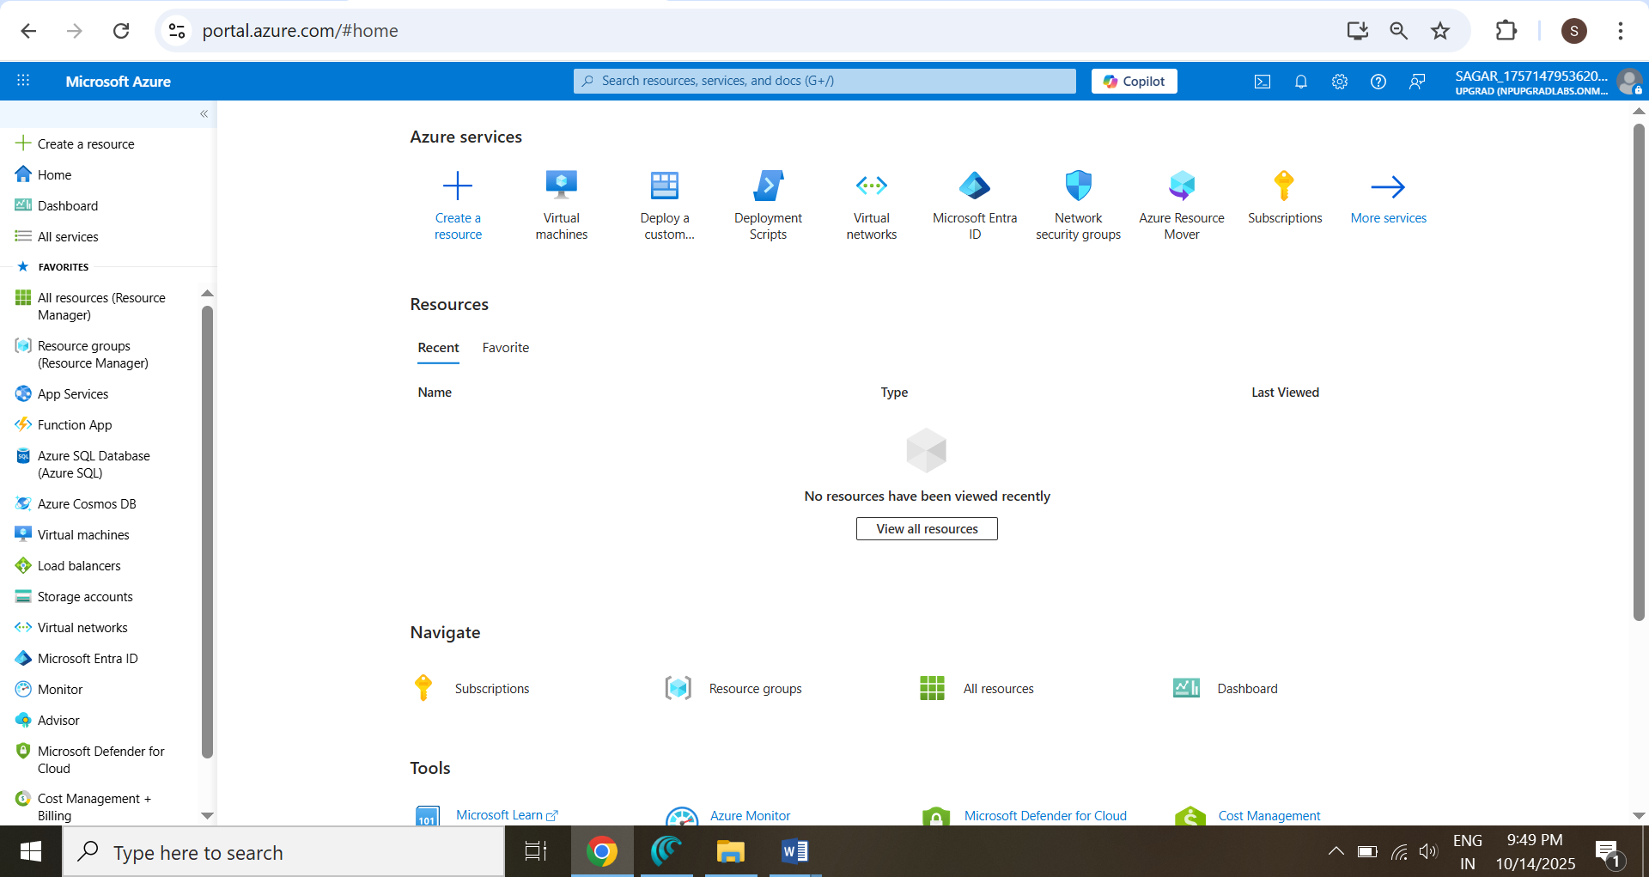

1. **Start Custom Deployment**
   * Search → **“Deploy a custom template”** → click **Build your own template in the editor**.

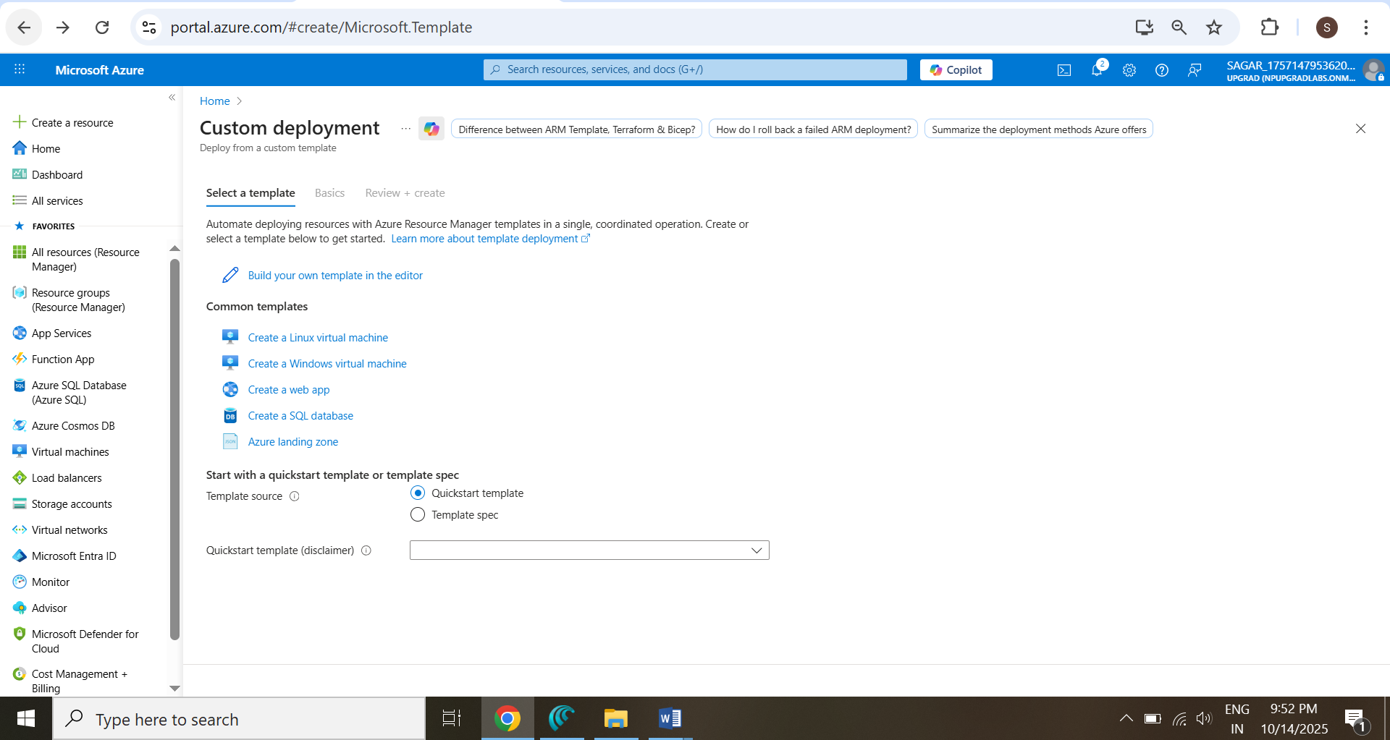

1. **Upload ARM Template File**
   * Click **Load file → select** [Azure_Project_ARM.json](https://github.com/sagarpatilbox/upgrad-azure-project/blob/main/Azure_Project_ARM.json)
   * Click **Save**.

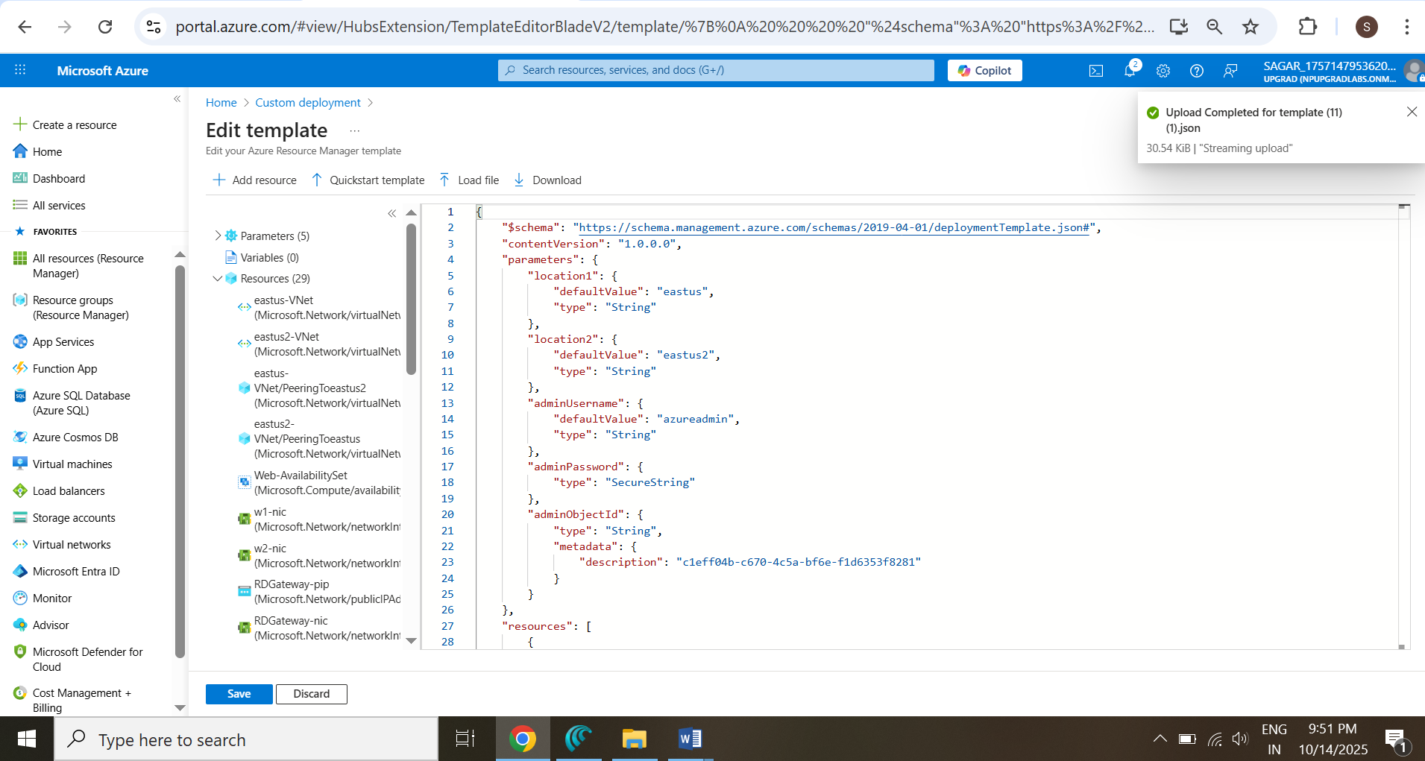

1. **Configure Deployment Parameters**
   * **Subscription** → choose active subscription.
   * **Resource Group** → “Create new” → upgrad-rg-azure-project.
   * Region → **West US**.
   * **Fill parameters** (adminUsername, adminPassword, adminObjectId).
   * Copy Object ID From Below :

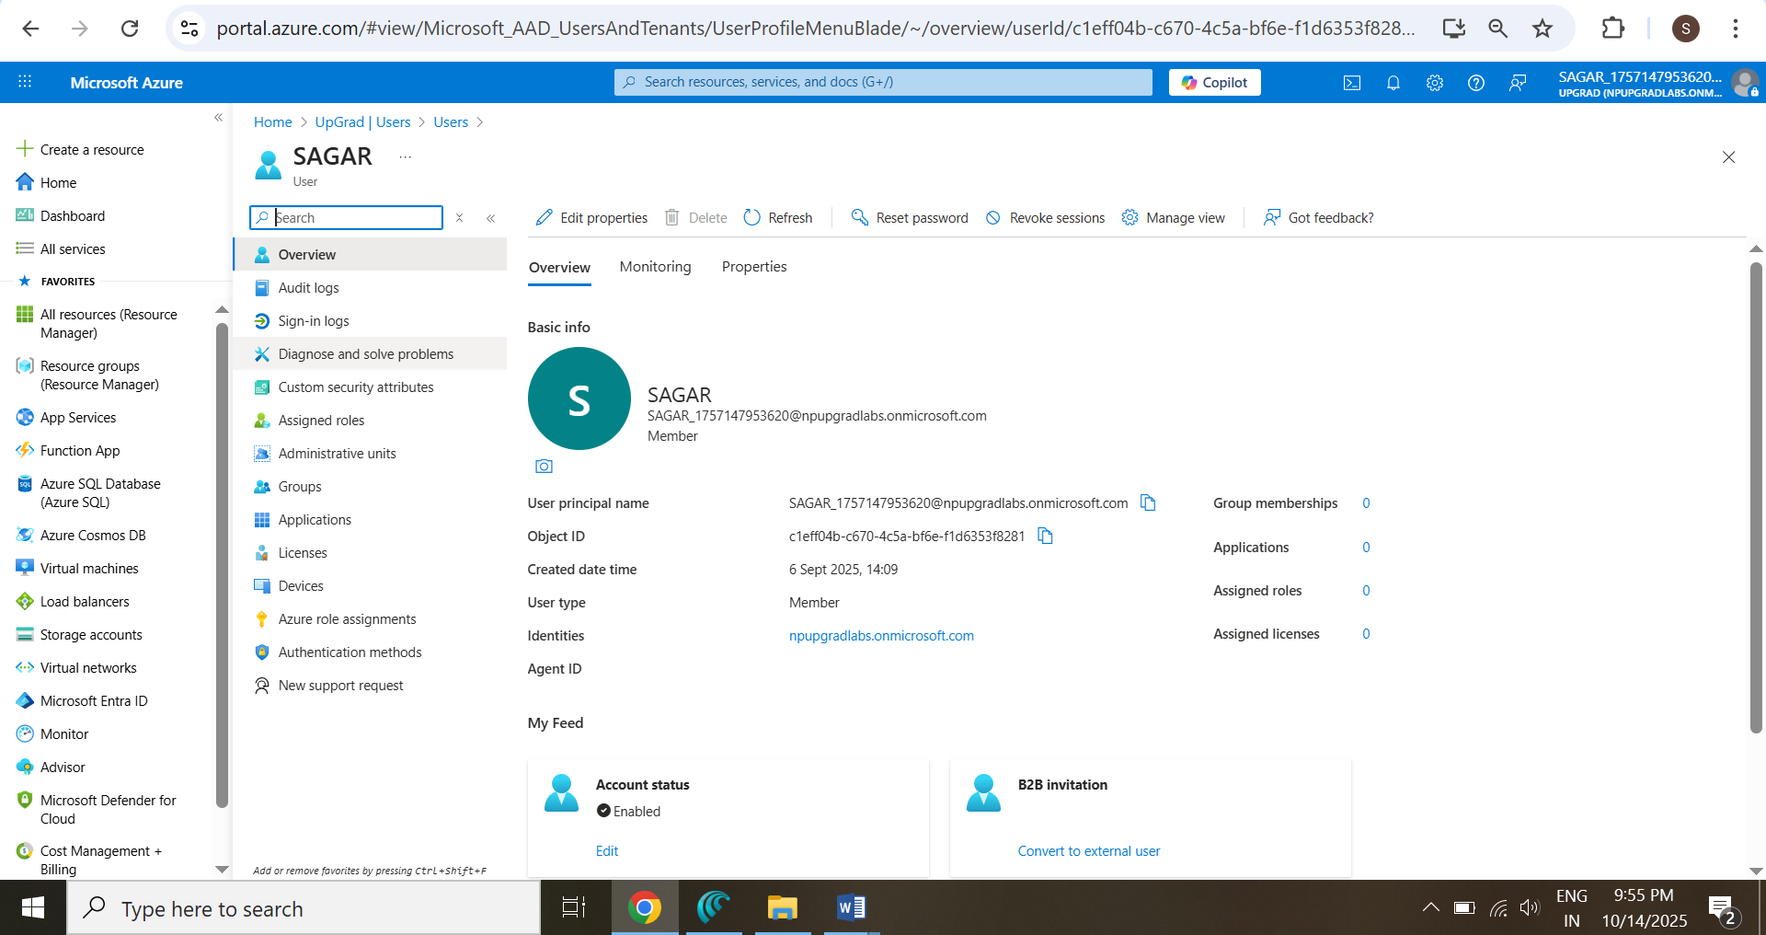

* + Click **Review + Create → Create**.

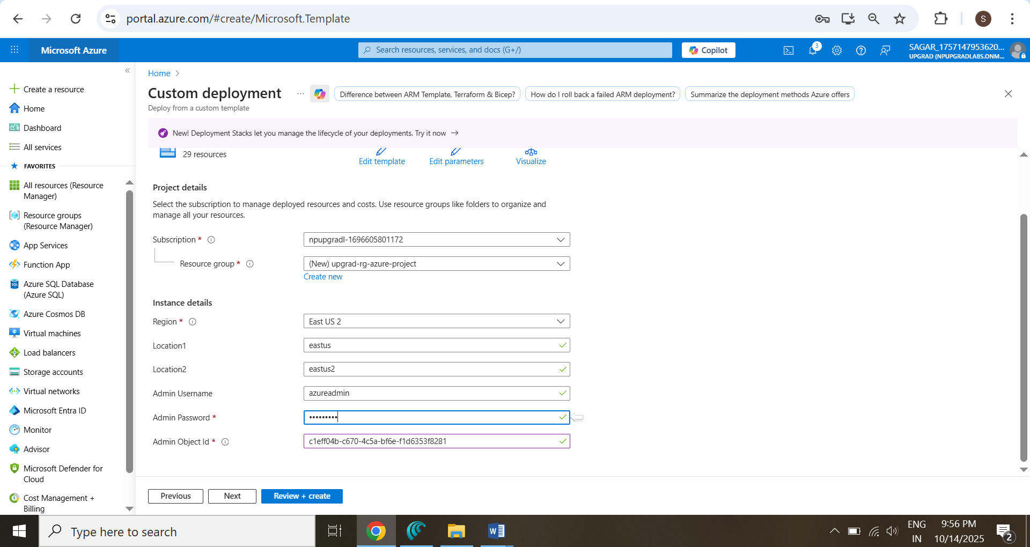

1. **Monitor Deployment Progress**
   * Portal → **Notifications** → view progress.

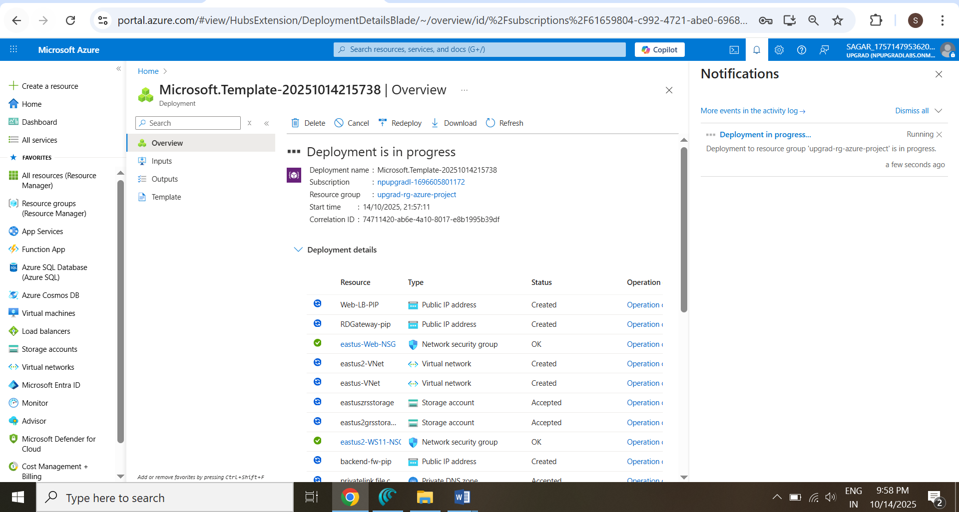

1. **Deployment Outputs**
   * Once succeeded 🡪 **Go to Resource Group**

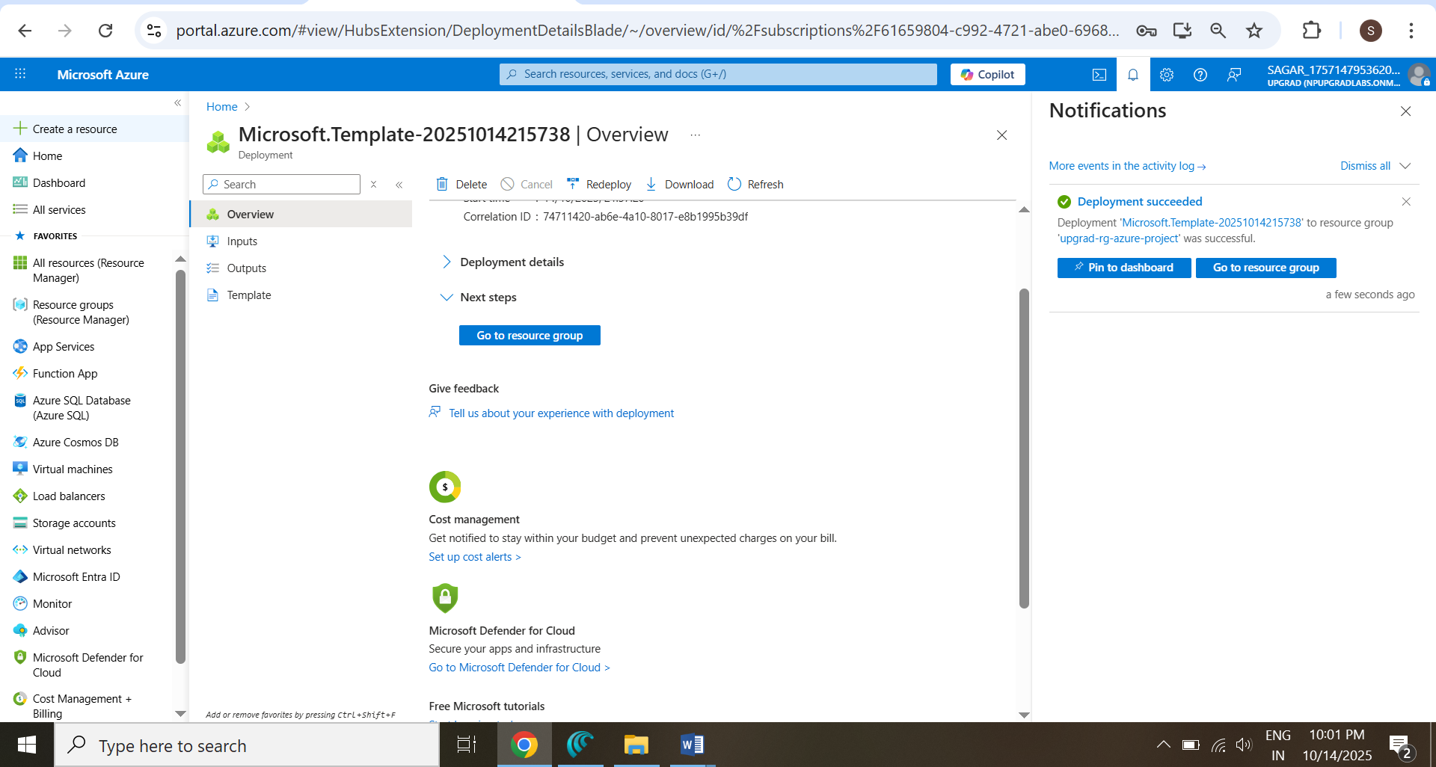

### **Verification**

* **Resource Group** upgrad-rg-azure-project created.

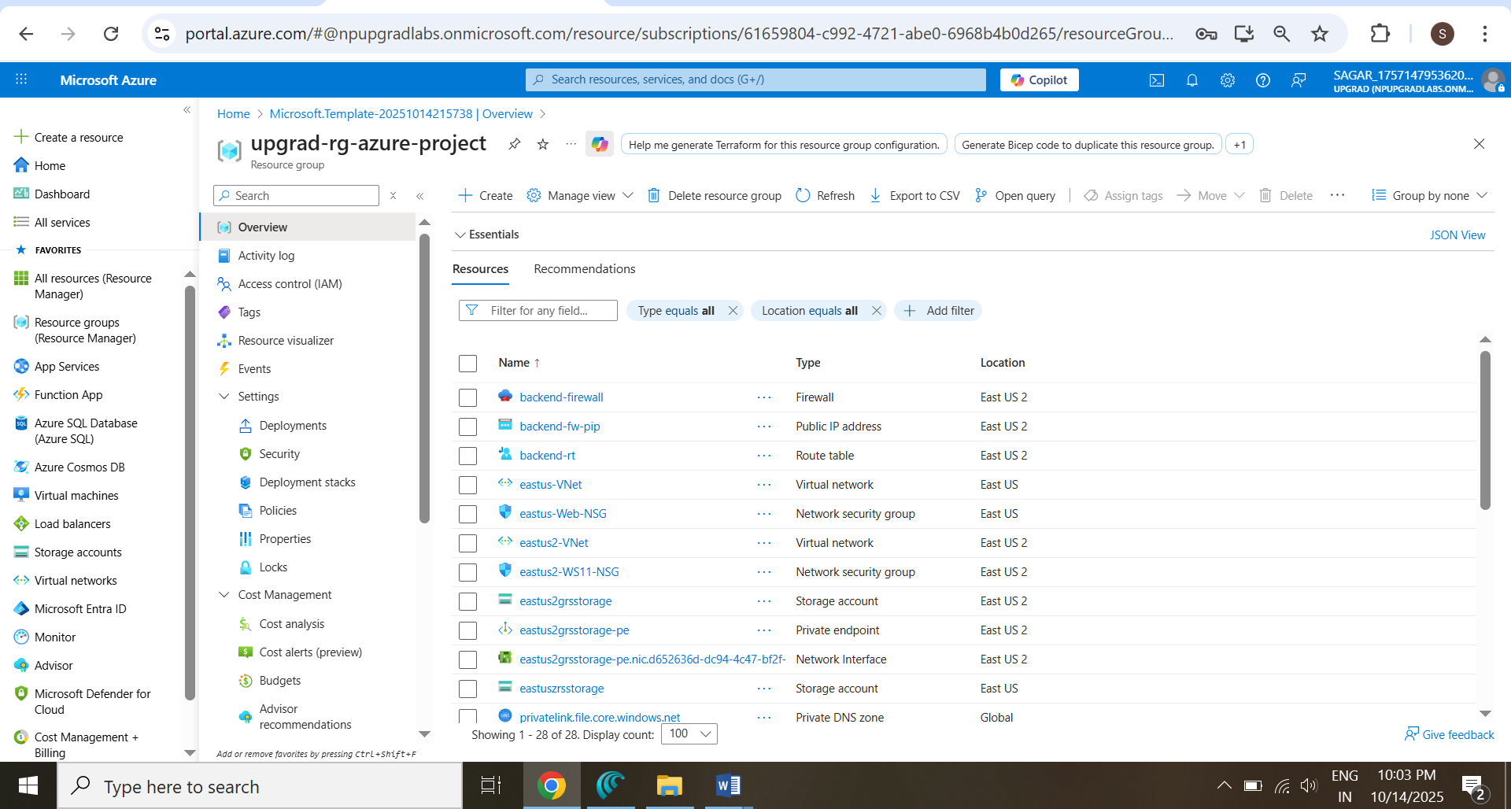

* **VNets** eastus-VNet and eastus2-VNet visible under **Virtual networks**.

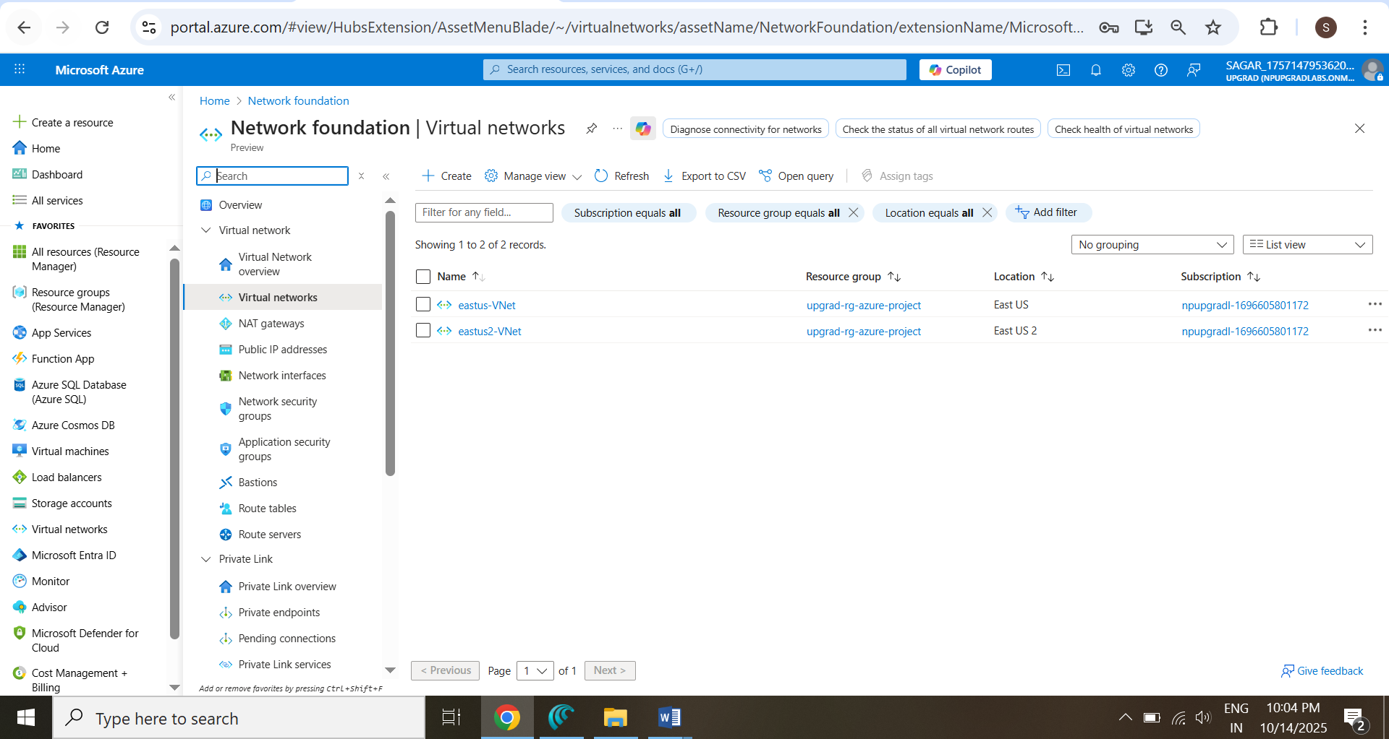

* **Subnets** (websubnet, RDGatewaySubnet, GatewaySubnet) correctly created in **eastus-VNet**

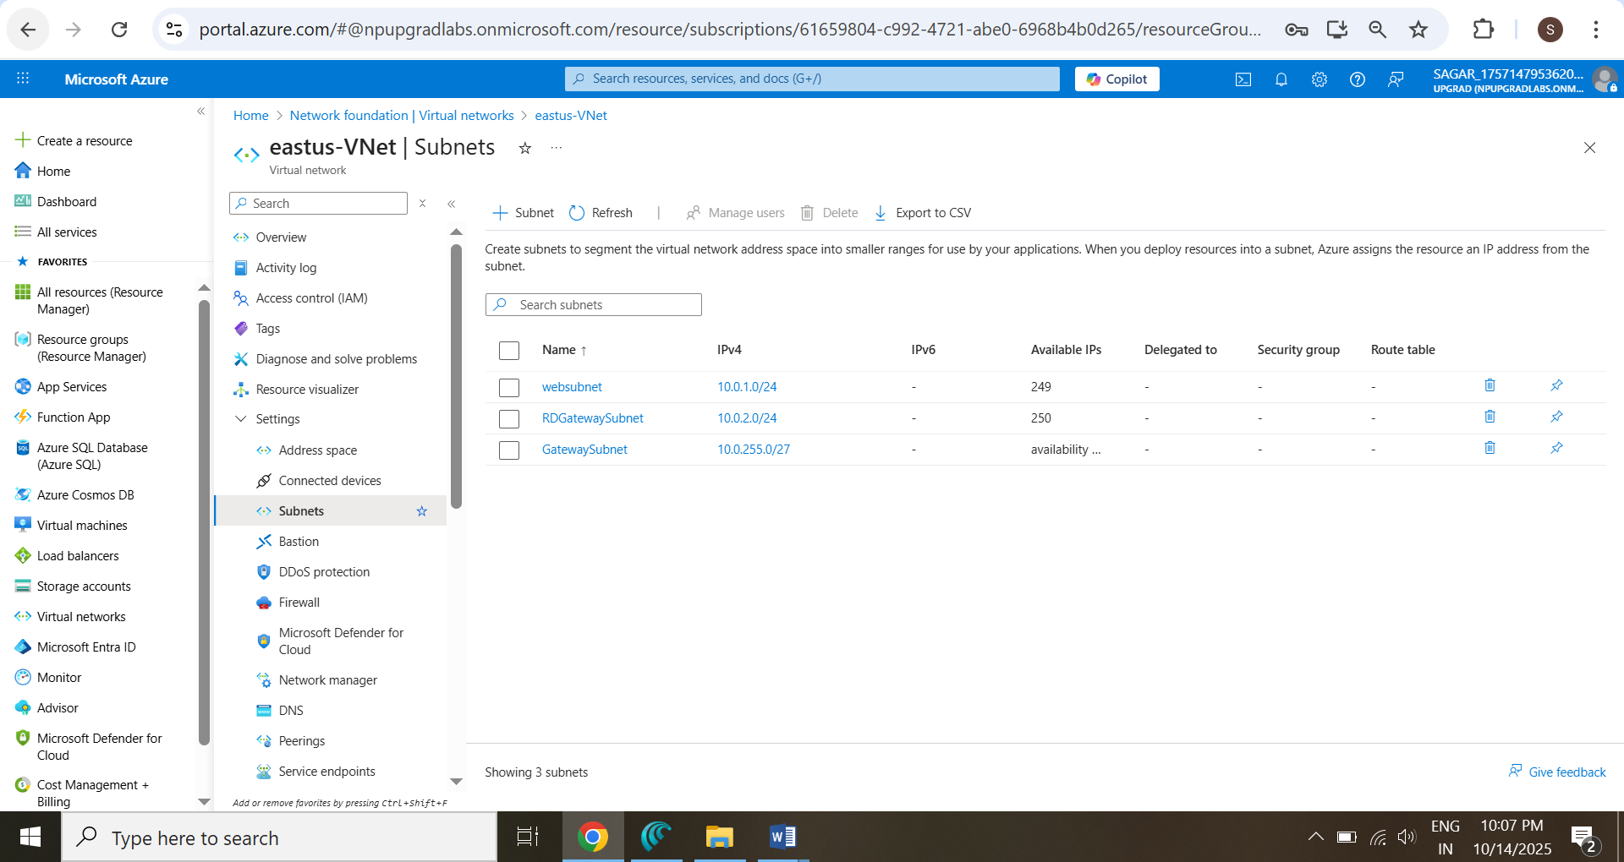

* **Subnets** (appsubnet, AzureFirewallSubnet, GatewaySubnet) correctly created in **eastus2-VNet**

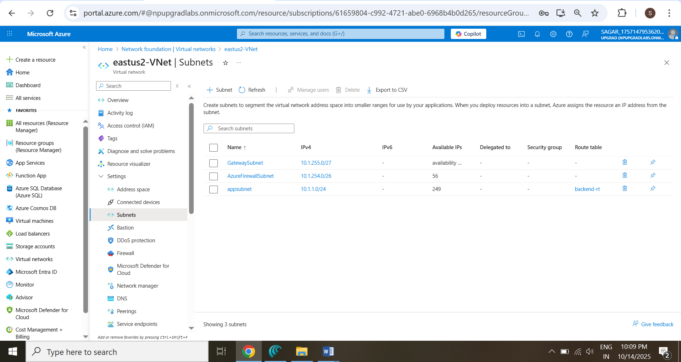

## **Task II — Deploy Virtual Machines**

### Objective

Deploy web servers, RD Gateway, and WS11 backend server with high availability.

### Steps

1. **Verify Availability Set**

* **Portal** → **Availability sets** → Web-AvailabilitySet.

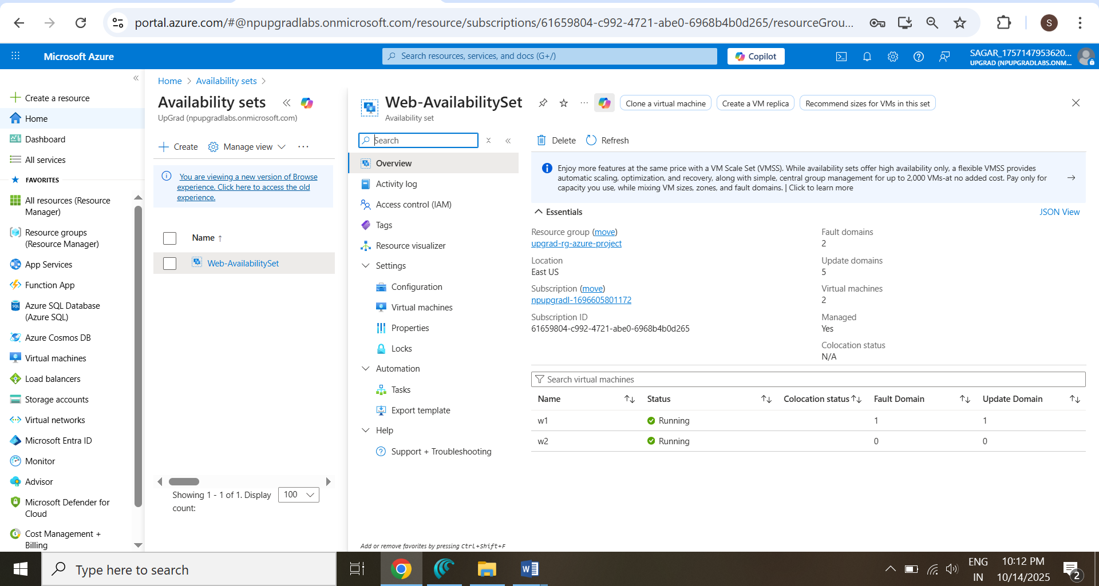

1. **Confirm Virtual Machines**
   * **w1, w2, RDGateway, WS11** visible in **Virtual Machines**.

**RDGateway 🡪**

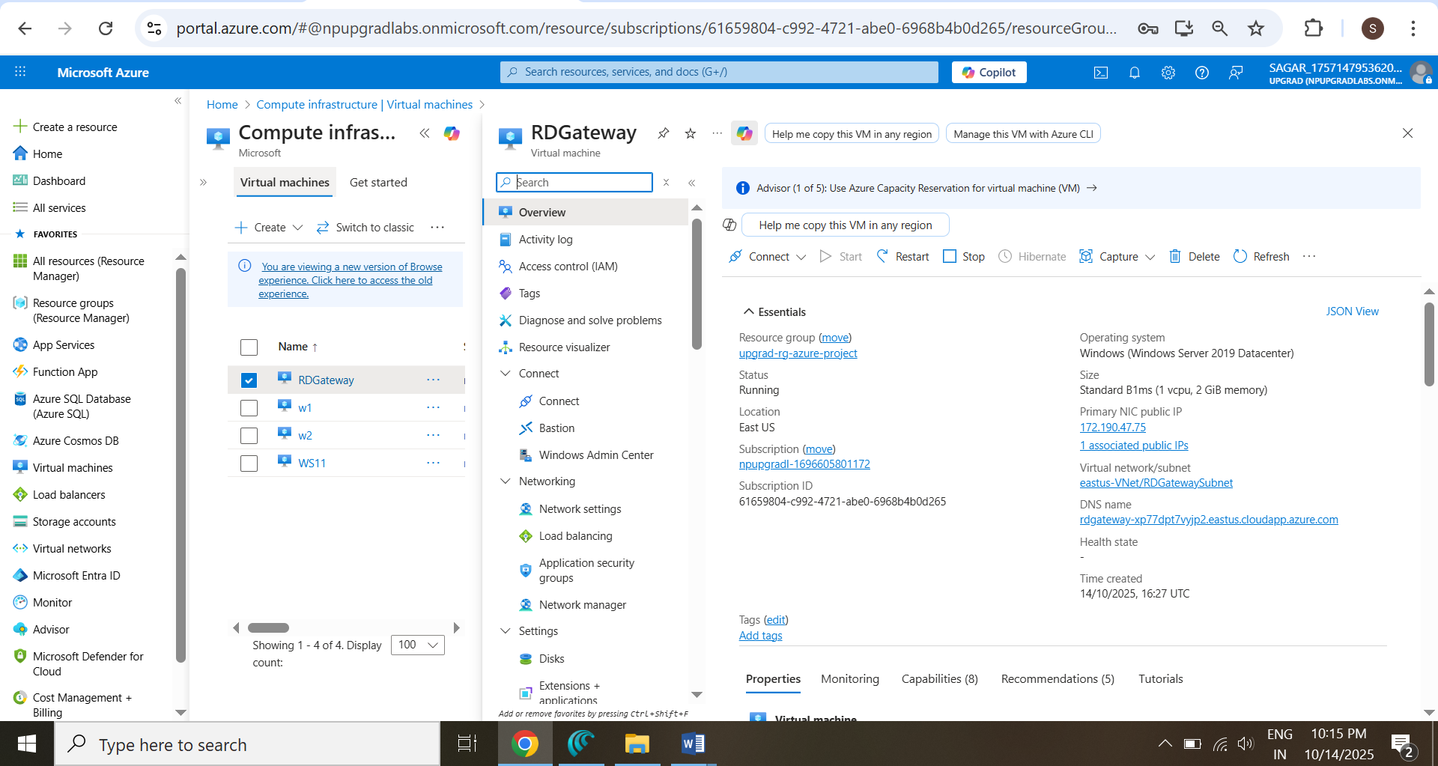

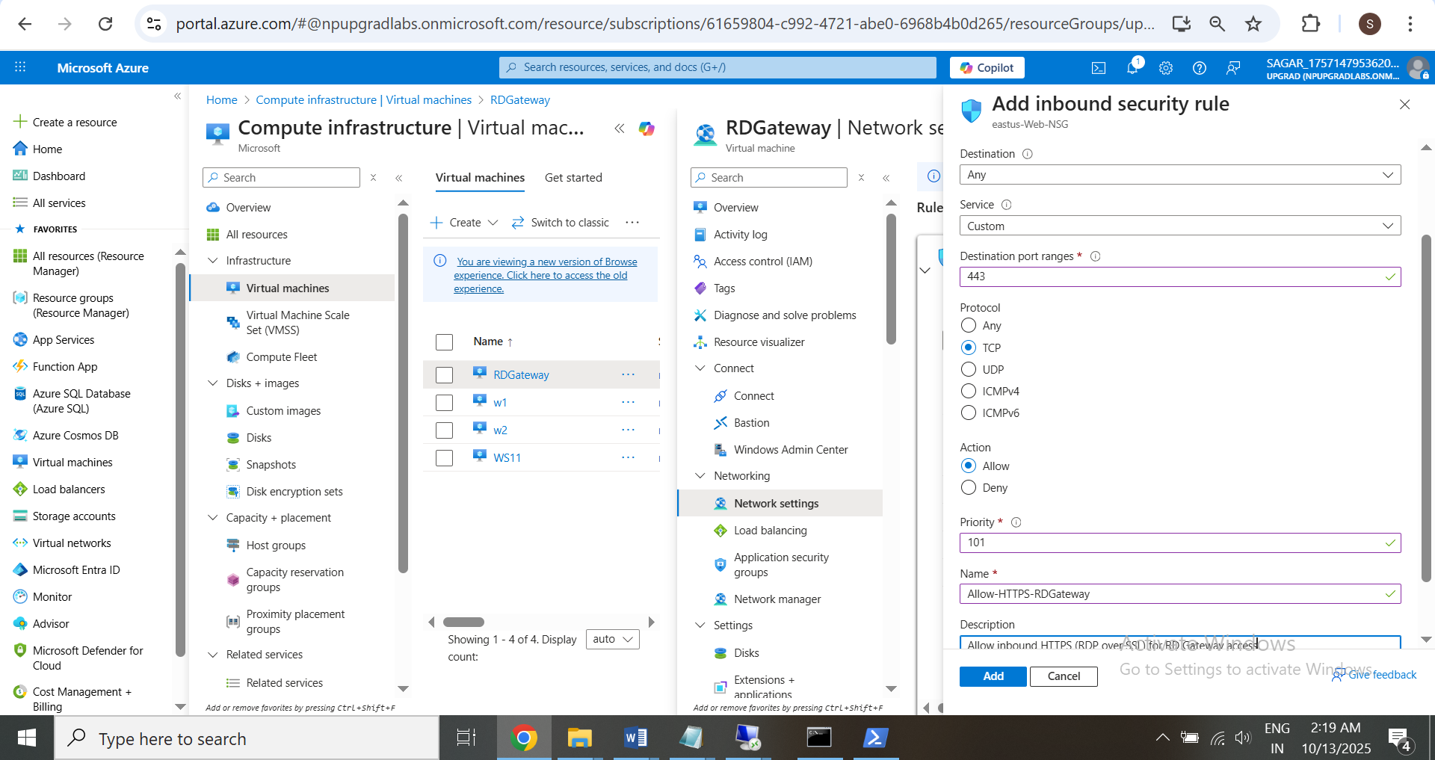

**W1 🡪**

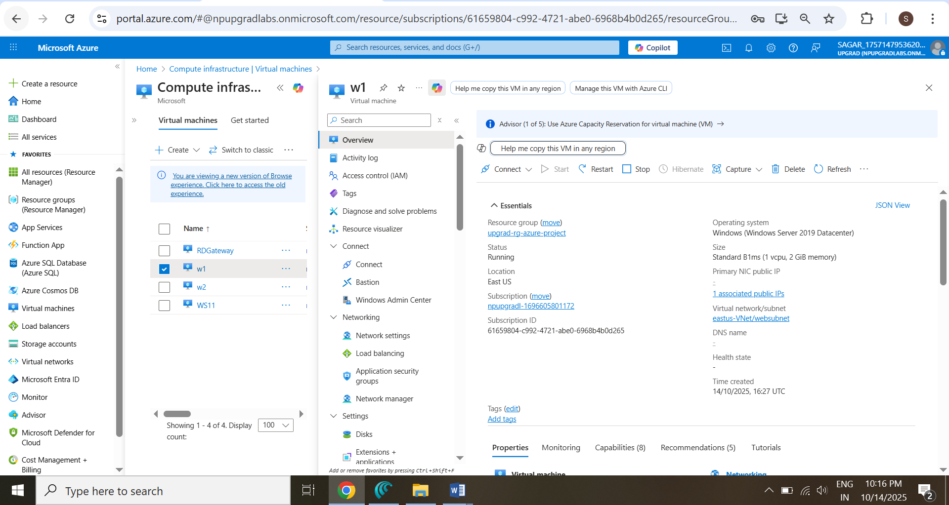

**W2 🡪**

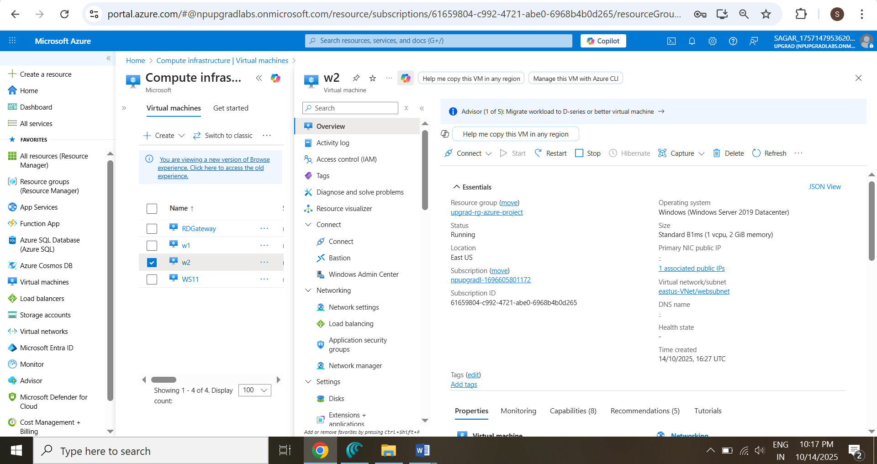

**WS11 🡪**

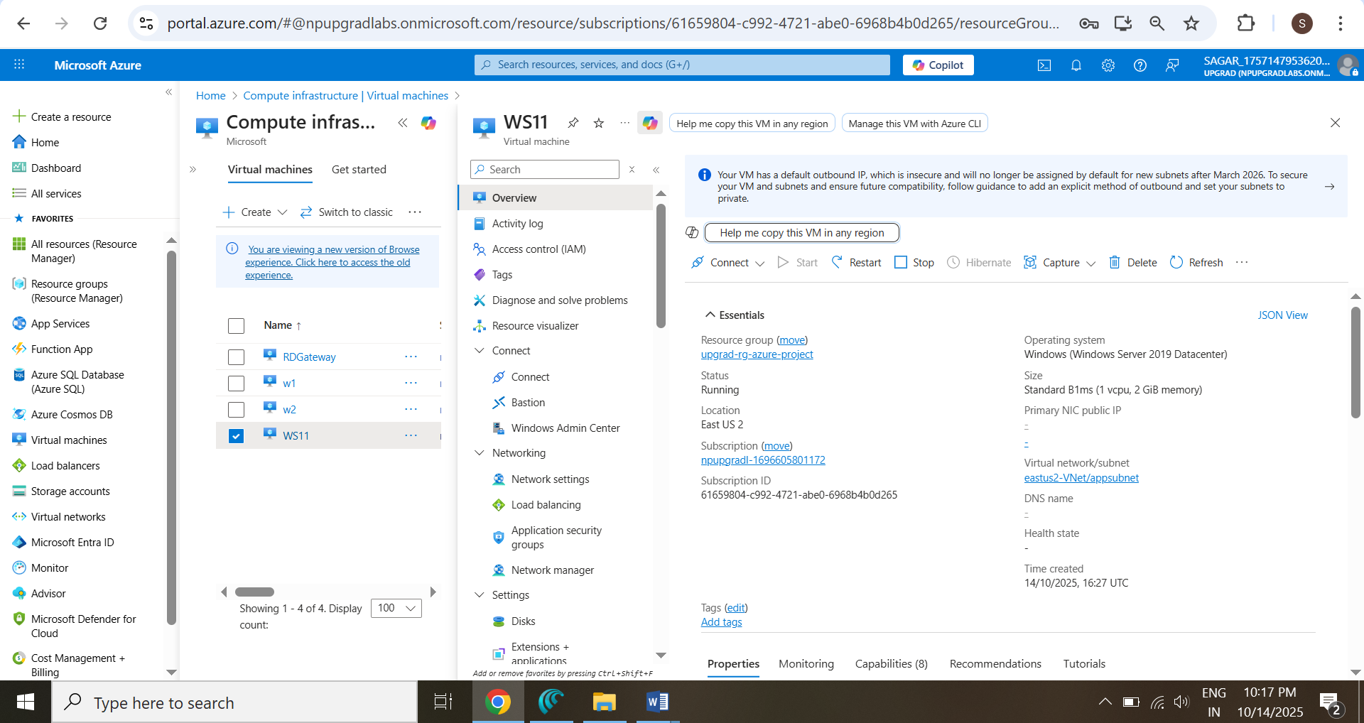

Virtual Machines 🡪

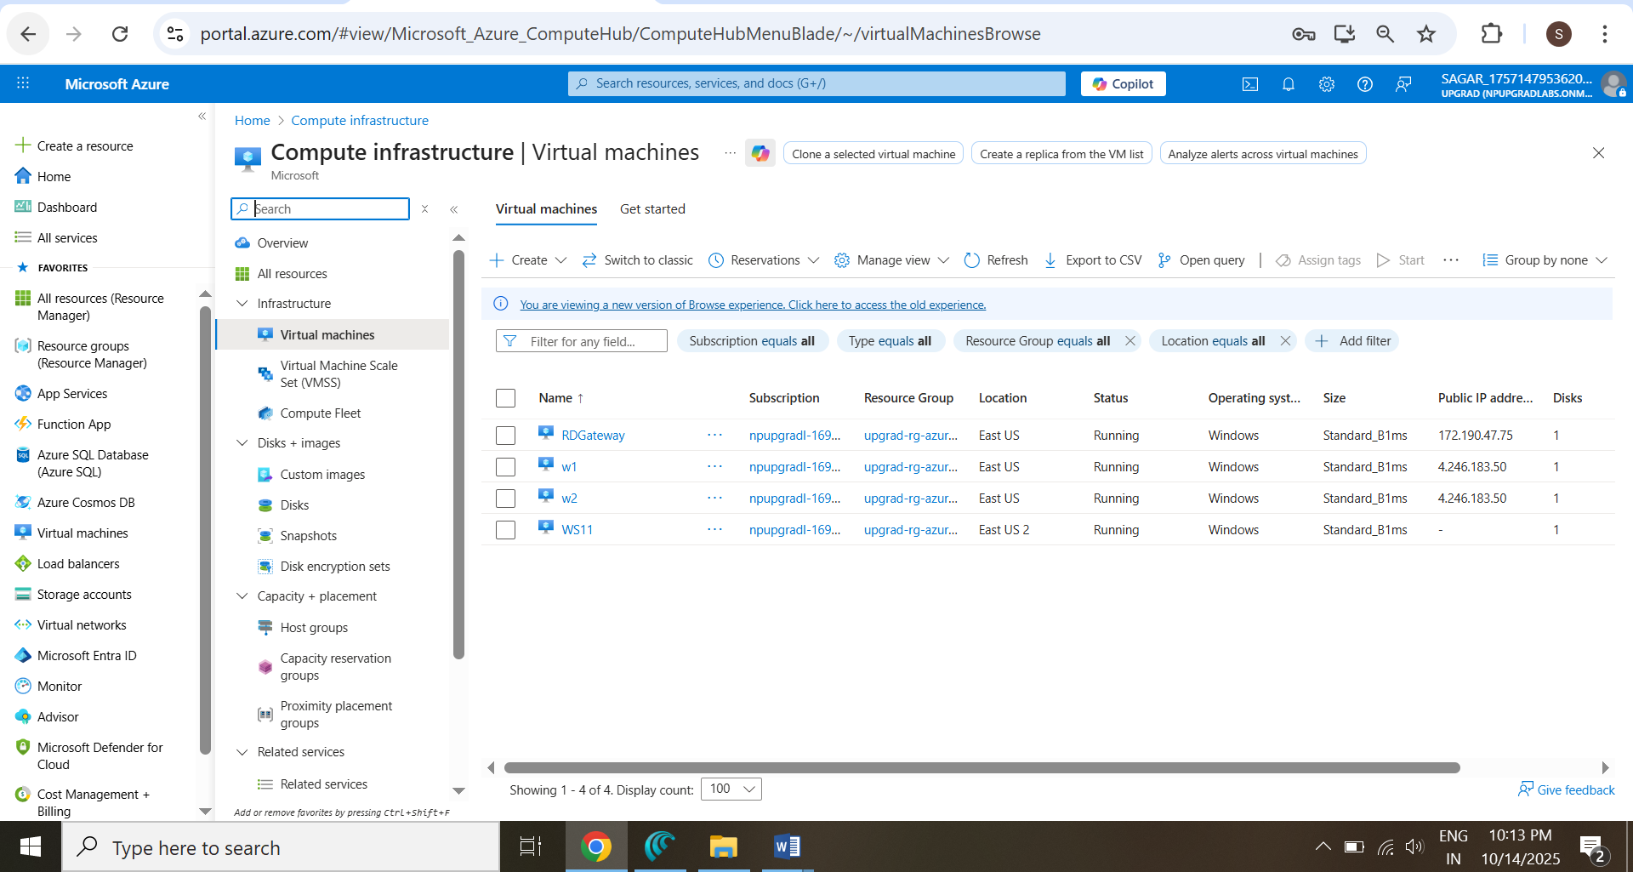

1. **Check VNet Peering**
   * **eastUS-VNet** → **Peerings** → Confirm “Connected” to **eastUS2-VNet**.

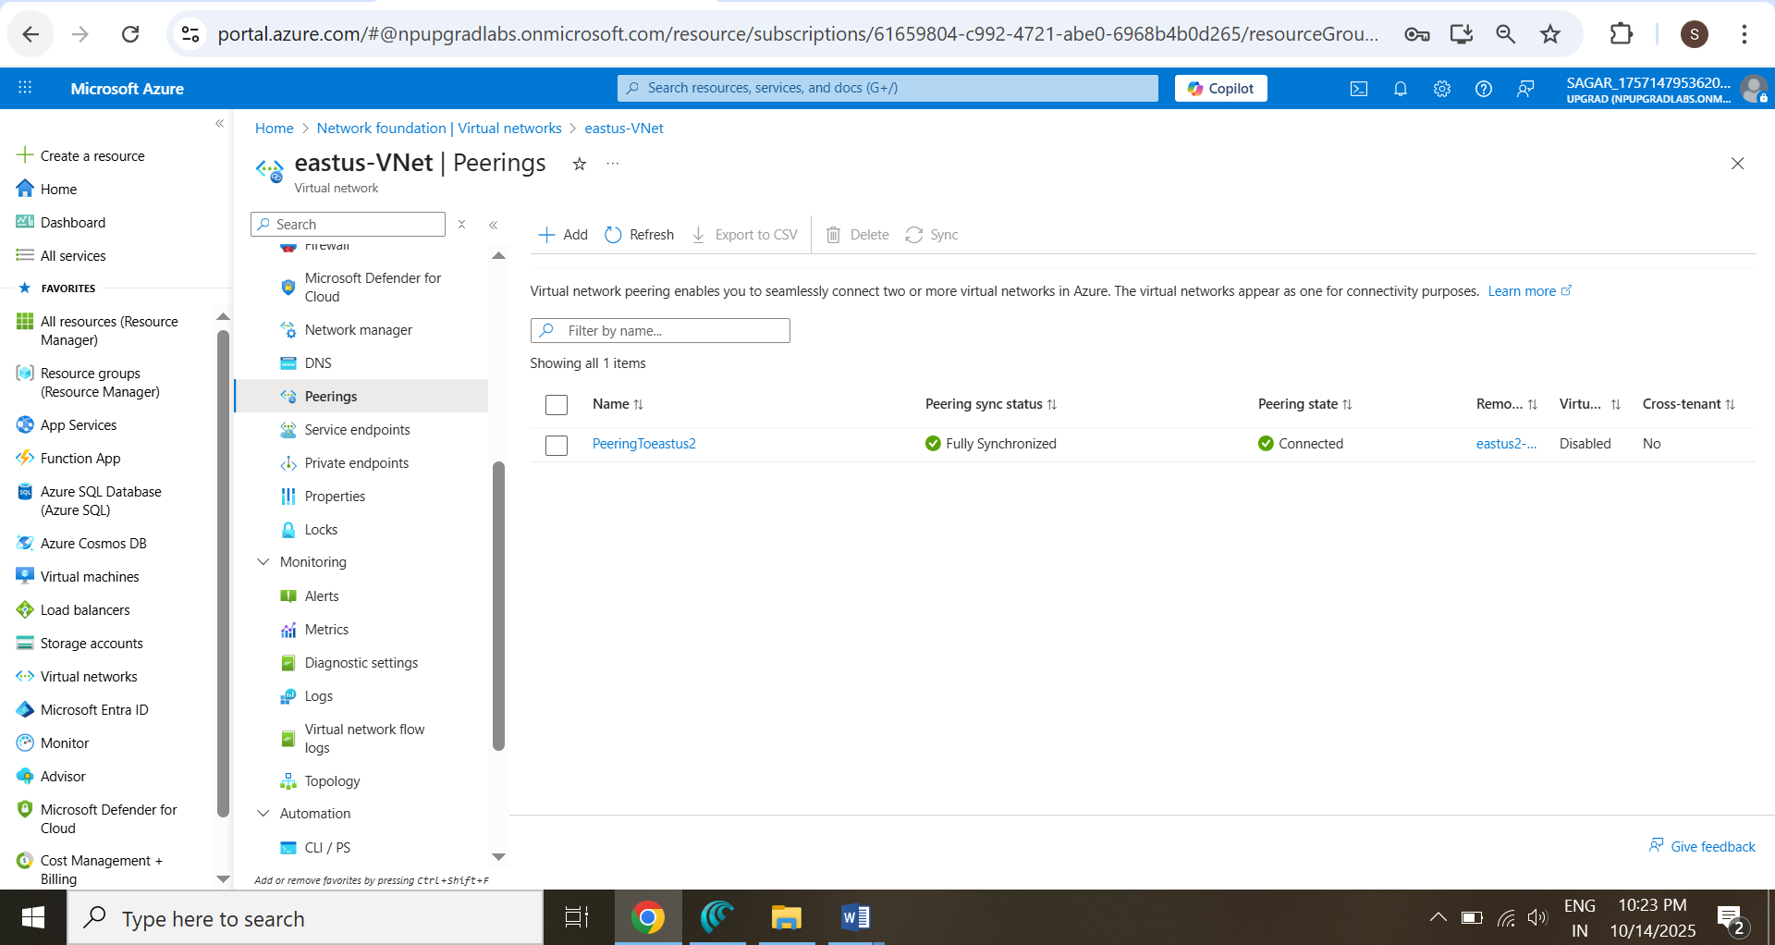

* + Vice versa **eastUS2-VNet → Peerings** → Confirm “Connected” **to eastUS-VNet**

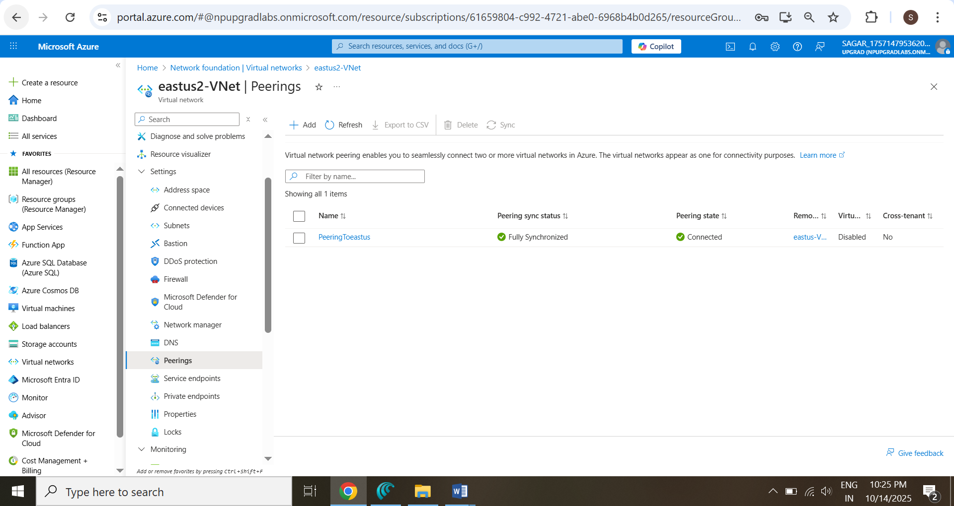

### **Verification**

* W1 and W2 deployed in EastUS under availability set. 🡪 Done above
* RDGateway has public IP. 🡪 Done above
* WS11 deployed in EastUS2 (private IP only). 🡪 Done above
* Peering between VNets connected. 🡪 Done above

## **Task III — Implement Secure Connectivity**

### Objective

Establish secure access and restricted communication using NSGs, VPN/Private Link, and Load Balancer.

### Steps

1. **Load Balancer Configuration**
   * Portal → Load Balancers **→ Web-LB.**

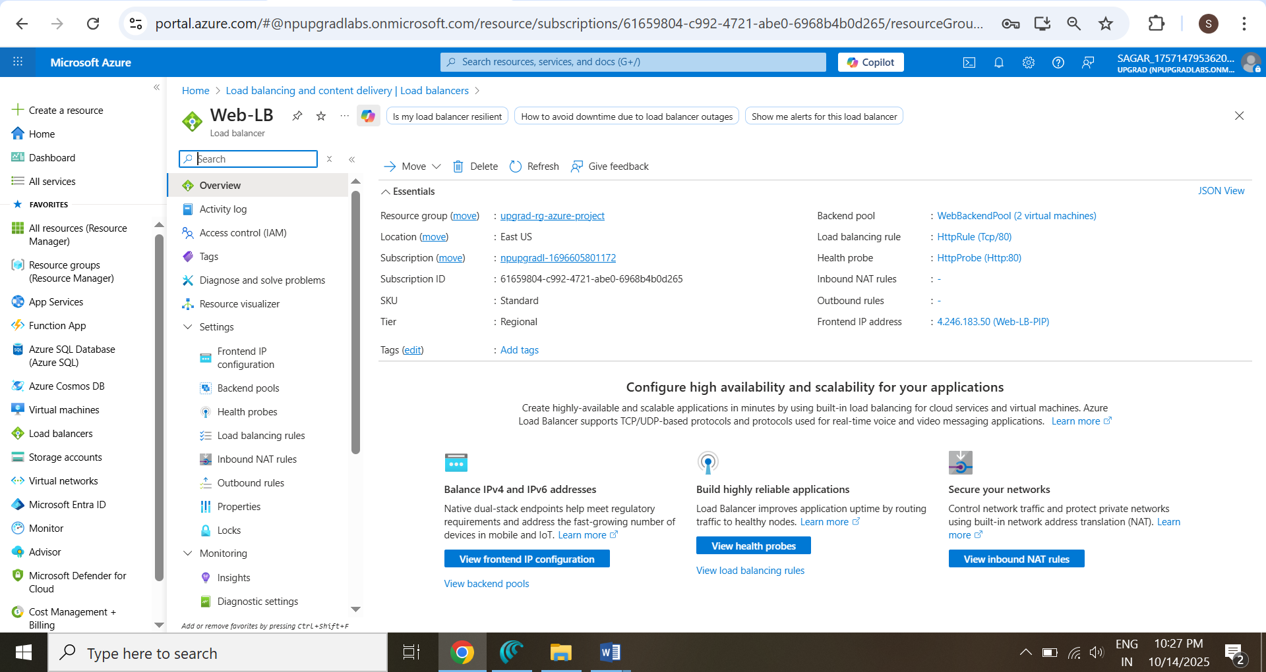

* + Verify Frontend IP, Backend Pool, and Health Probe.

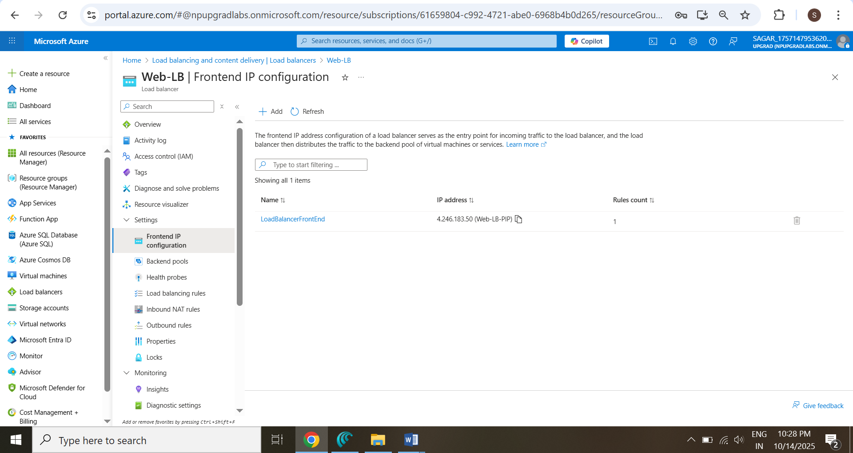

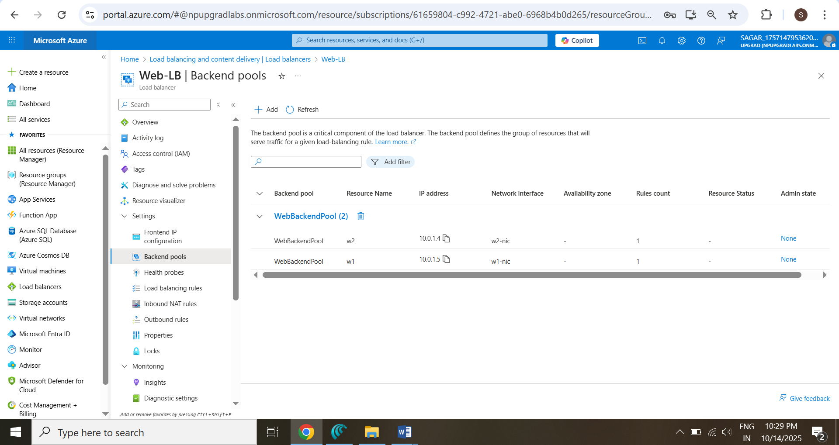

**Health Probe :**

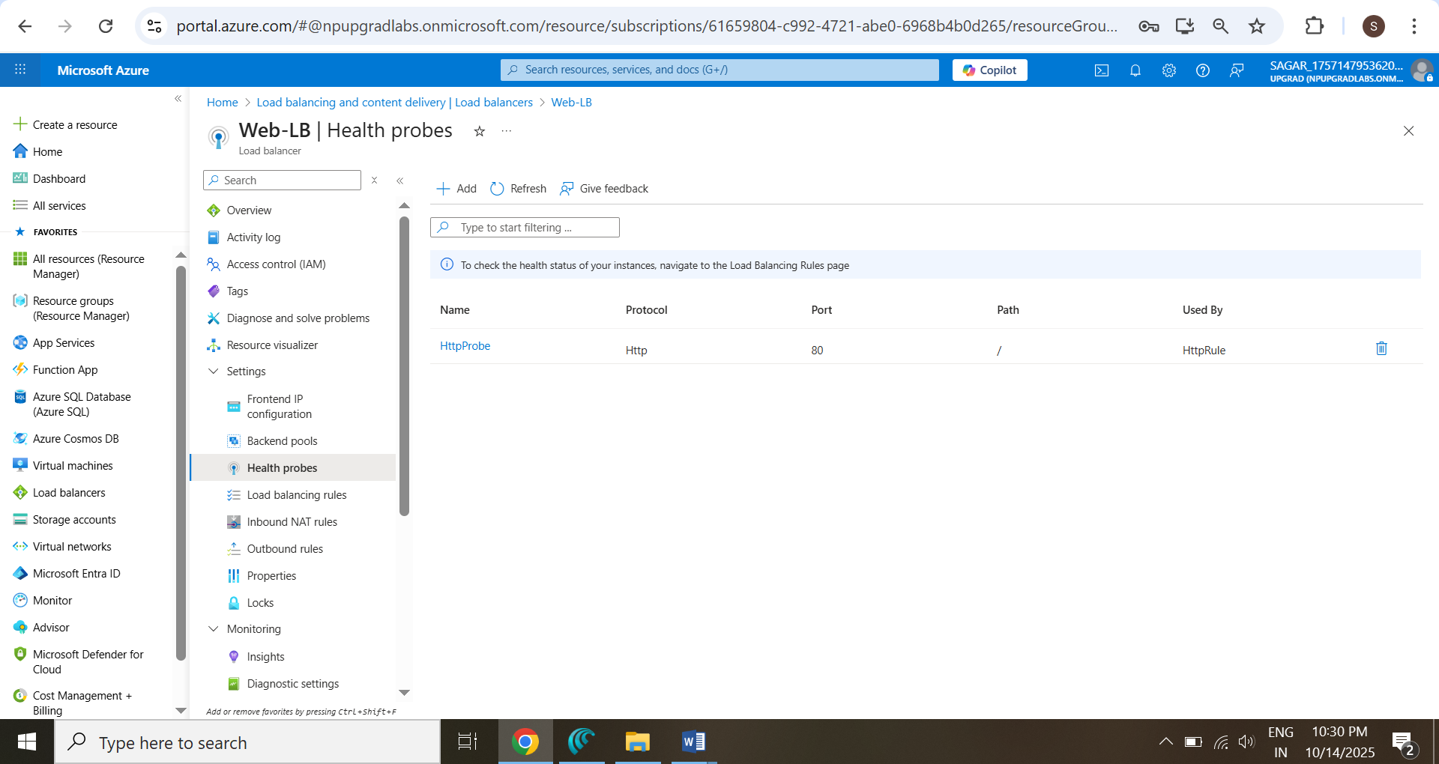

1. **Network Security Groups (NSGs)**
   * **EastUS-Web-NSG** allow **HTTPS (443), RDP (3389).**

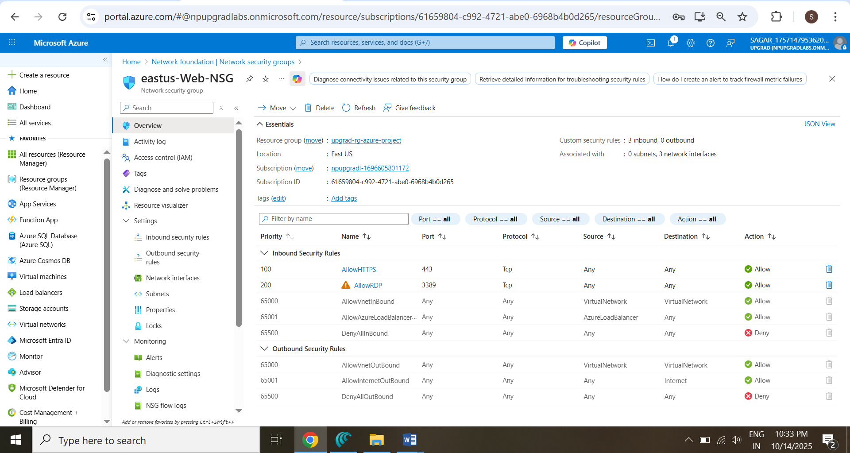

* + **EastUS2-WS11-NSG** deny **outbound to social media** sites.

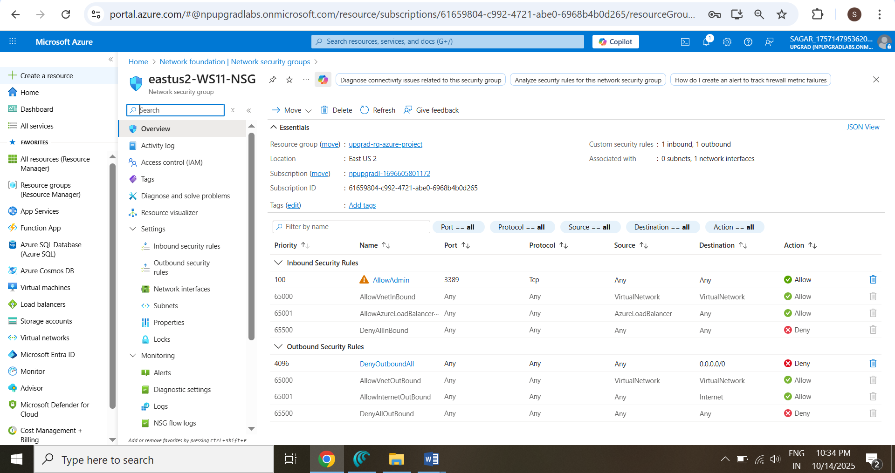

1. **Secure Communication**
   * Confirm encrypted traffic **between VNets.**

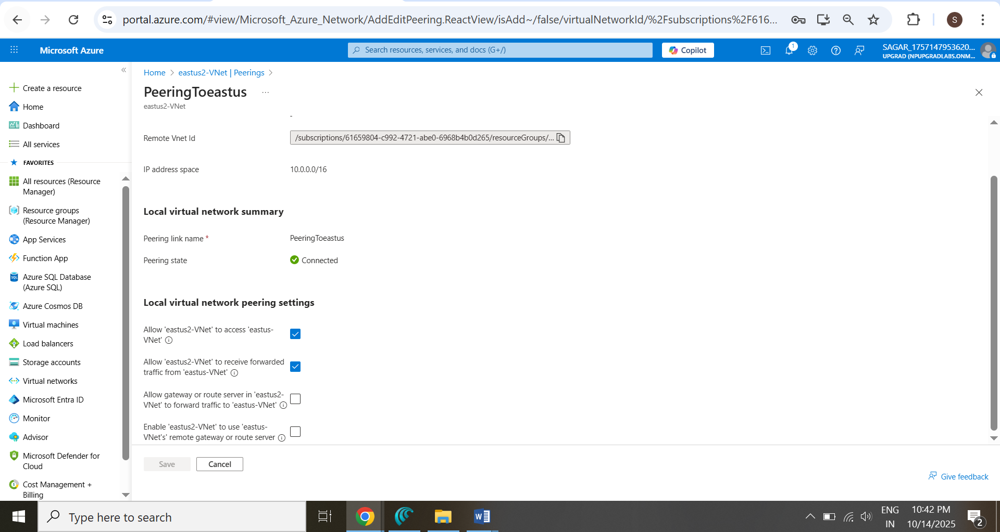

1. **Azure Private Link Verification**

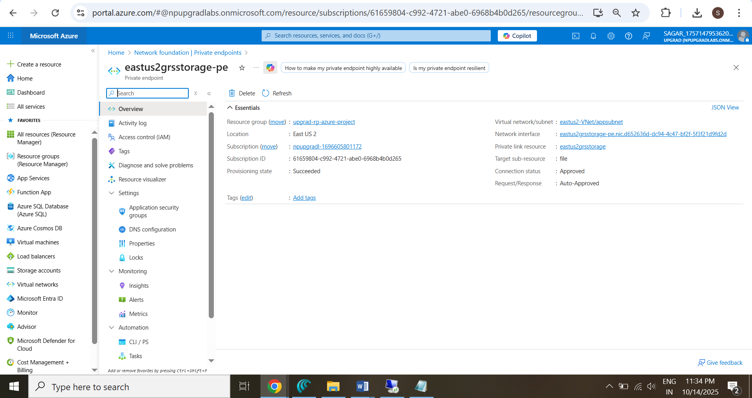

### **Verification**

* LB public IP reachable.

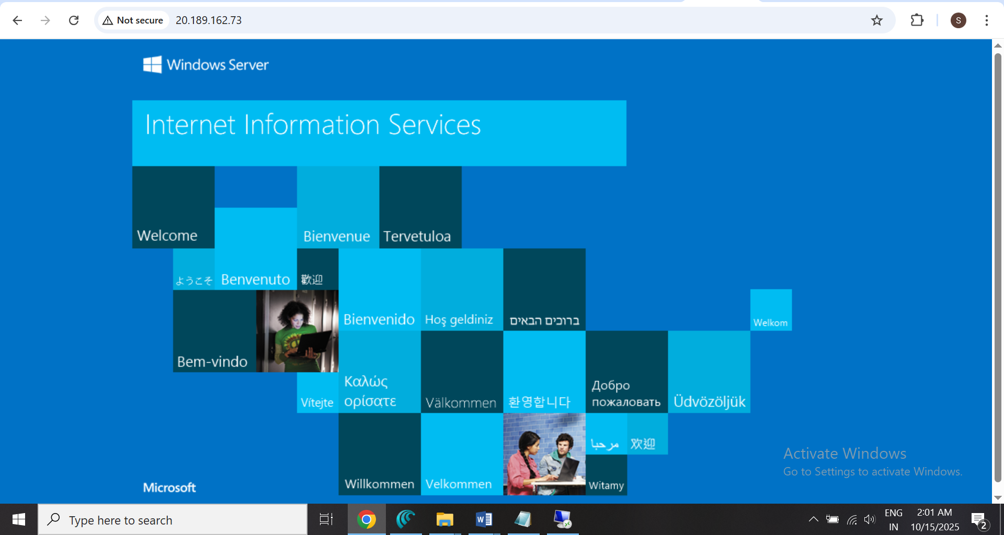

* w1 & w2 appear in backend pool.



**RD Gateway & RD Web Access — GUI-based Setup (Windows Server 2022/2025)**

* **STEP 1 — Install Roles via Server Manager**

1. Open **Server Manager → Manage → Add Roles and Features**.
2. Choose **Role-based or feature-based installation**, click **Next**.
3. Select **This server**.
4. In **Server Roles**, check:
   * **Remote Desktop Gateway**
   * **Remote Desktop Web Access**
   * IIS and Management Tools will auto-select → keep them.
5. Click **Next** until **Install**.
6. Wait for installation to complete → **Close**.

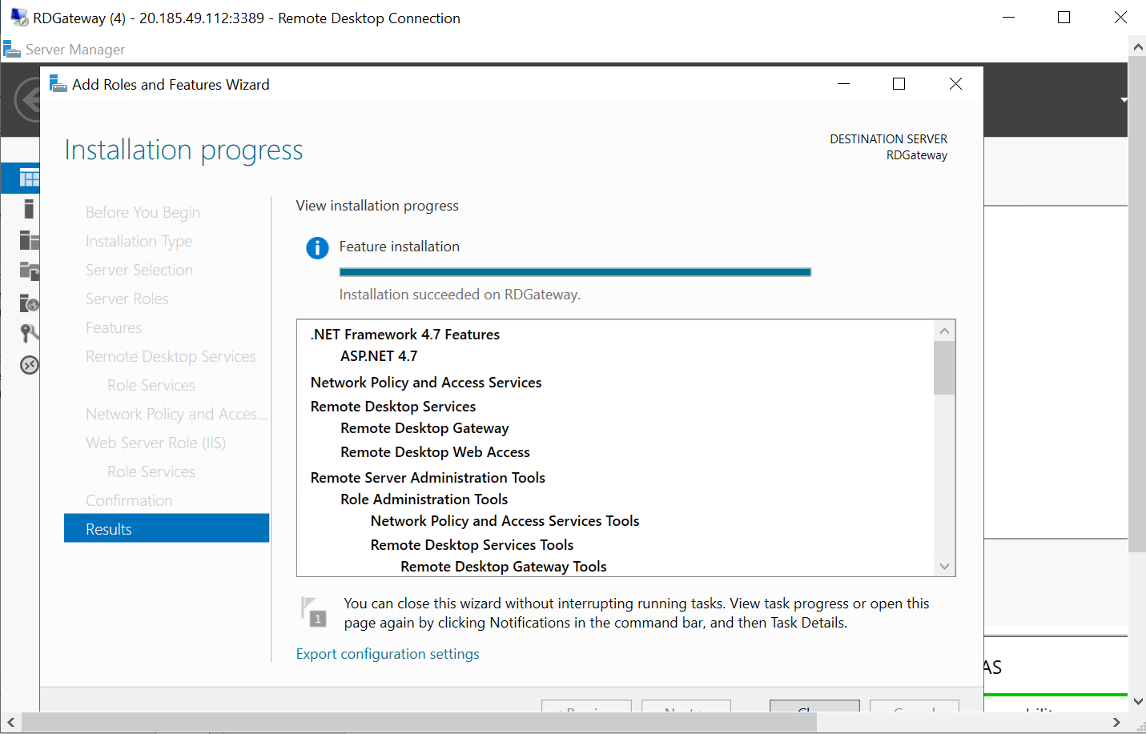

* **STEP 2 — Verify Roles Installed**
* Open **Server Manager → Dashboard → Remote Desktop Services**.
* You should see **RD Gateway** and **RD Web Access** listed.
* Optionally, open **Programs and Features → Turn Windows features on/off** to confirm.

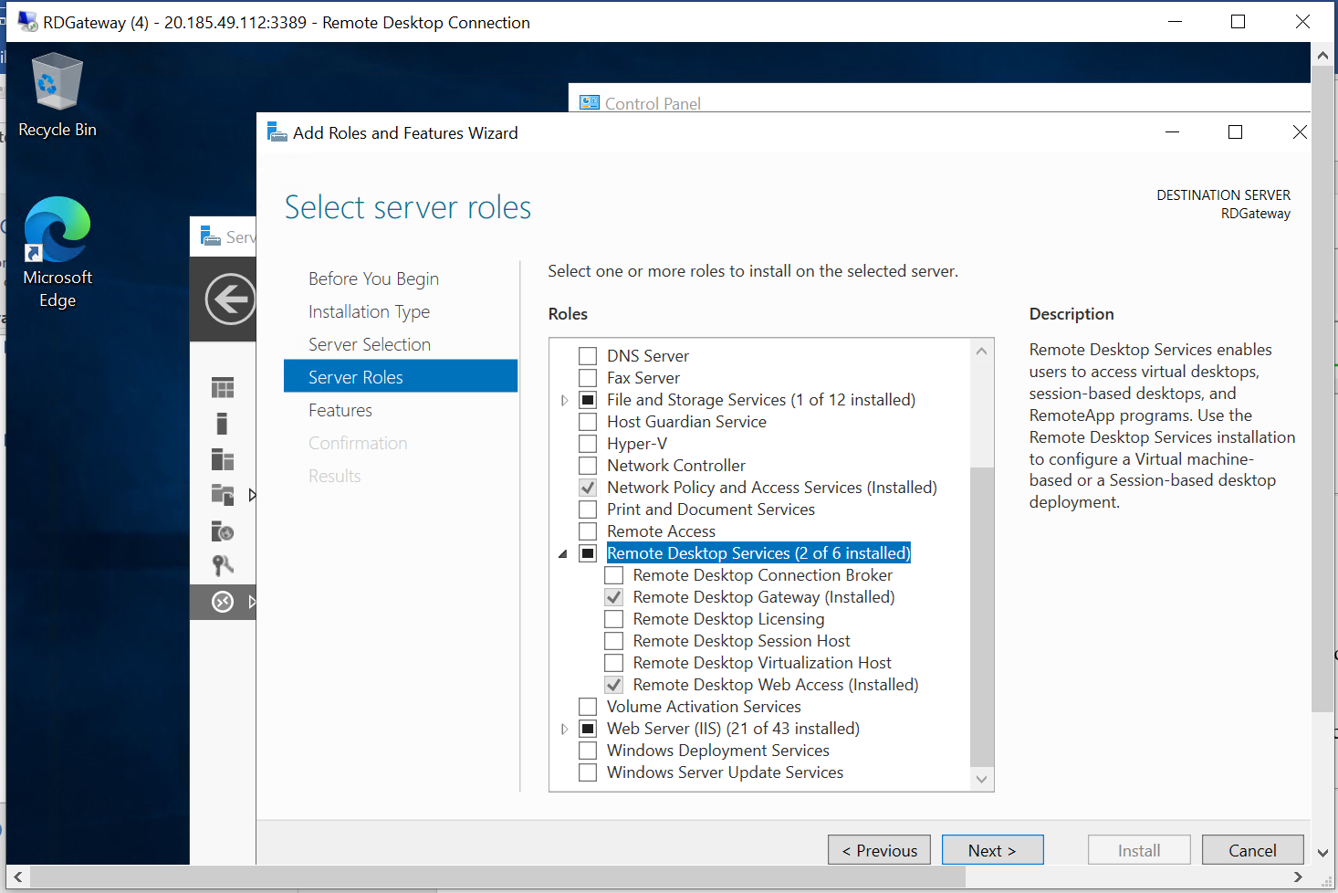

* **STEP 3 — Create a Valid HTTPS Certificate**

You can use **IIS Manager** or **Certificates MMC**. Using **Powershell**

# --- Step 3: Create self-signed certificate

$publicName = (Invoke-RestMethod -Uri "https://ifconfig.me/ip" -ErrorAction SilentlyContinue)

if (-not $publicName) { $publicName = (hostname) }

Write-Host "Creating self-signed certificate for $publicName..." -ForegroundColor Cyan

$cert = New-SelfSignedCertificate `

-DnsName $publicName `

-CertStoreLocation "cert:\LocalMachine\My" `

-FriendlyName "RDGatewayCert" `

-KeyExportPolicy Exportable `

-TextExtension @("2.5.29.37={text}1.3.6.1.5.5.7.3.1") `

-NotAfter (Get-Date).AddYears(2)

$thumb = $cert.Thumbprint

Write-Host "Certificate thumbprint: $thumb"

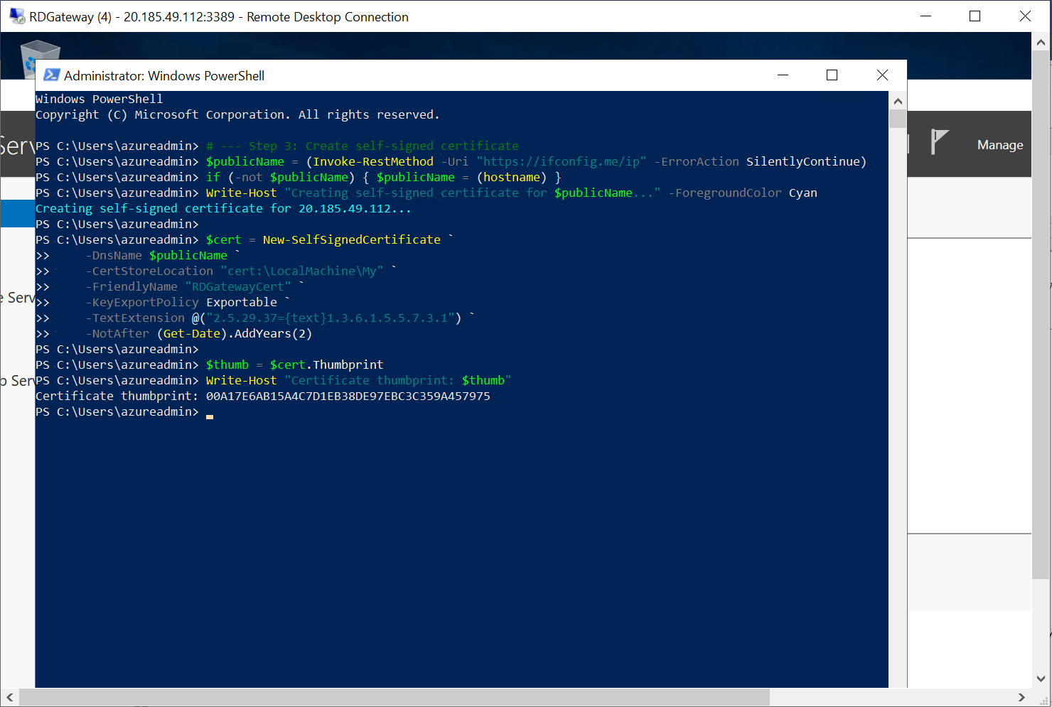

* **IIS Manager**

1. Open **IIS Manager** → click server name (left pane).
2. Double-click **Server Certificates** (center).
3. In right Actions pane → click **Create Self-Signed Certificate**.
4. Name it: RDGW-SelfSigned-20.185.49.112.
5. Choose **Personal** store → OK.

* **STEP 4 — Bind Certificate to IIS (HTTPS 443)**

1. In **IIS Manager** → expand **Sites → Default Web Site**.
2. Right pane → click **Bindings…**.
3. Click **Add…** →
   * Type: https
   * IP address: All Unassigned or your public IP
   * Port: 443
   * SSL certificate: choose the cert you just created
   * Click **OK** → then **Close**.

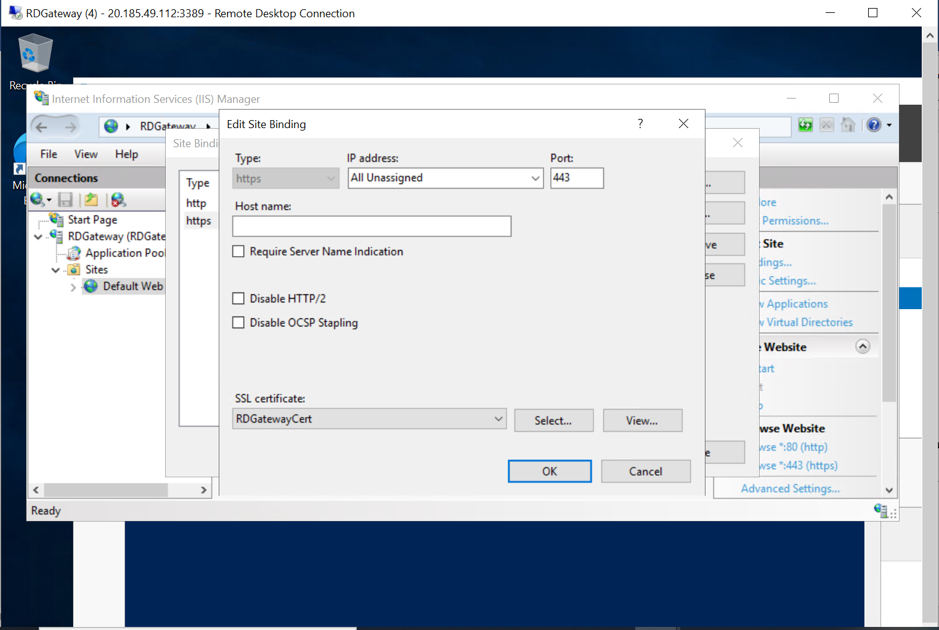

* **STEP 5 — Bind Certificate to RD Gateway**

1. Open **RD Gateway Manager** (tsgateway.msc).
2. Right-click server name → **Properties**.
3. Go to **SSL Certificate** tab.
4. Click **Import a certificate into the personal store**.
5. Select your certificate → click **Import**.
6. Once imported, select it and click **Apply**.

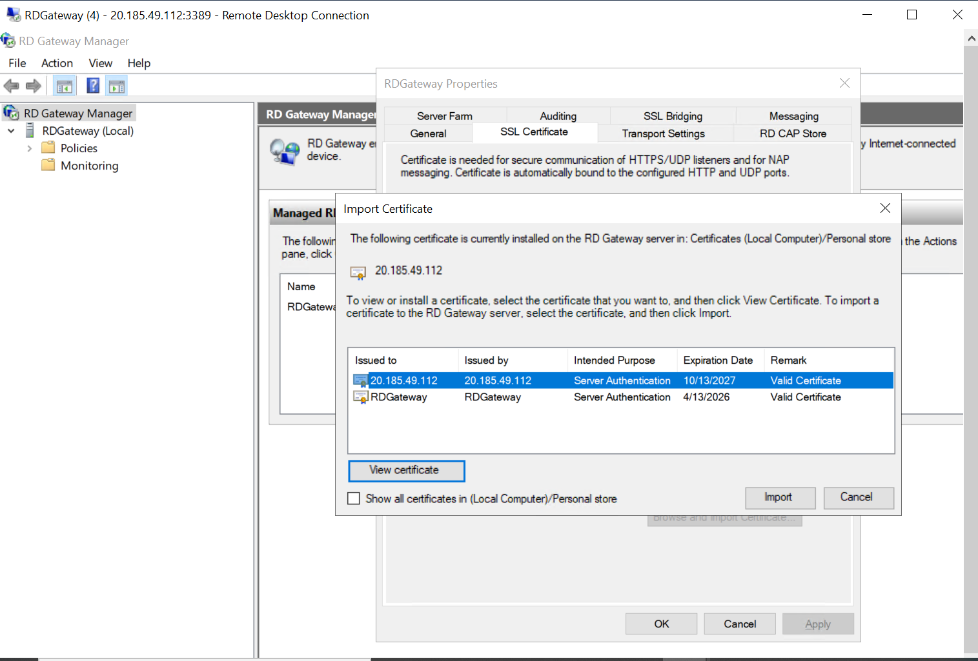

* **STEP 6 — Configure Firewall Rules (if needed)**

Windows usually enables these automatically.  
To verify:

1. Open **Windows Defender Firewall → Advanced settings**.
2. Click **Inbound Rules** → scroll to:
   * *World Wide Web Services (HTTP and HTTPS)*
   * *Remote Desktop Gateway*
3. Make sure **Enabled = Yes** and **Action = Allow**.

If not → right-click → **Enable Rule**.

Powershell Script 🡪

Write-Host "=== Enabling RD Gateway Firewall Rules ===" -ForegroundColor Cyan

$rules=@("World Wide Web Services (HTTP)","World Wide Web Services (HTTPS)","Remote Desktop Gateway","Remote Desktop")

foreach($r in $rules){

try{Enable-NetFirewallRule -DisplayGroup $r -ErrorAction Stop;Write-Host "✅ Enabled: $r"}

catch{if($r -match "HTTP" -and $r -notmatch "HTTPS"){New-NetFirewallRule -DisplayName "HTTP (80)" -Dir In -Protocol TCP -LocalPort 80 -Action Allow}

elseif($r -match "HTTPS"){New-NetFirewallRule -DisplayName "HTTPS (443)" -Dir In -Protocol TCP -LocalPort 443 -Action Allow}

elseif($r -match "Desktop"){New-NetFirewallRule -DisplayName "RDP (3389)" -Dir In -Protocol TCP -LocalPort 3389 -Action Allow}}}

Write-Host "✅ Firewall configuration complete." -ForegroundColor Green

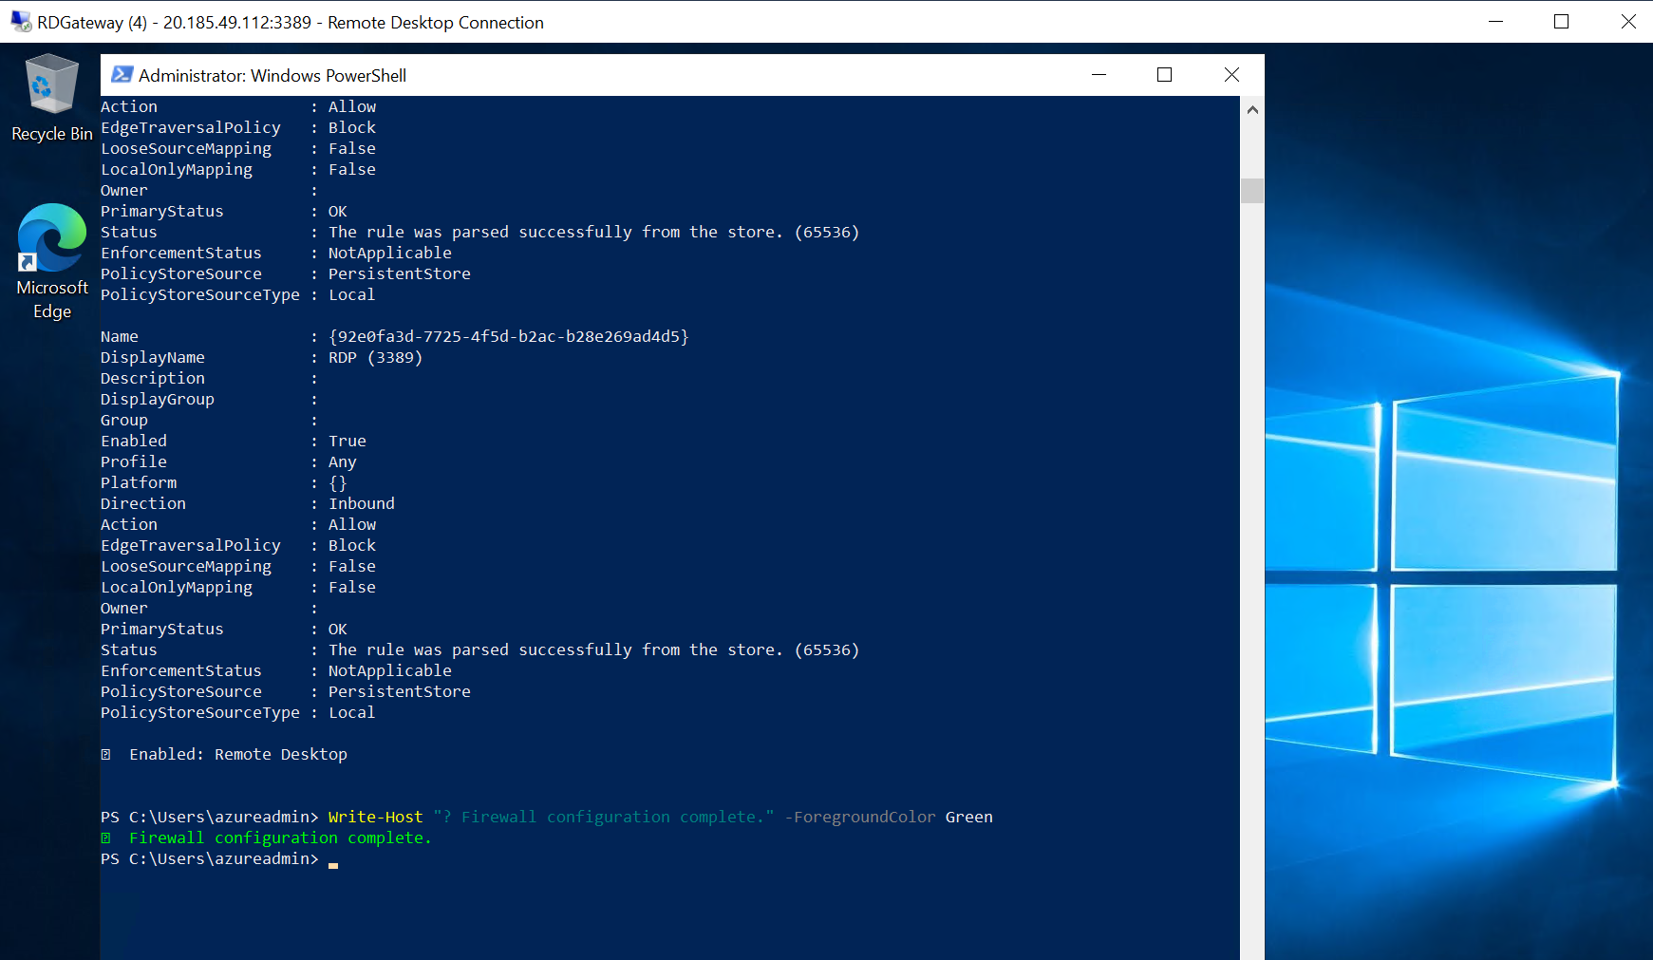

* **STEP 7 — Configure CAP and RAP (Access Policies)**

1. In **RD Gateway Manager**, expand your server → **Policies → Connection Authorization Policies** (CAP).

* Right-click → **Create New Policy.**
* Name: **Administrators-CAP.**
* Choose **User Group: Administrators.**
* Click **Finish.**

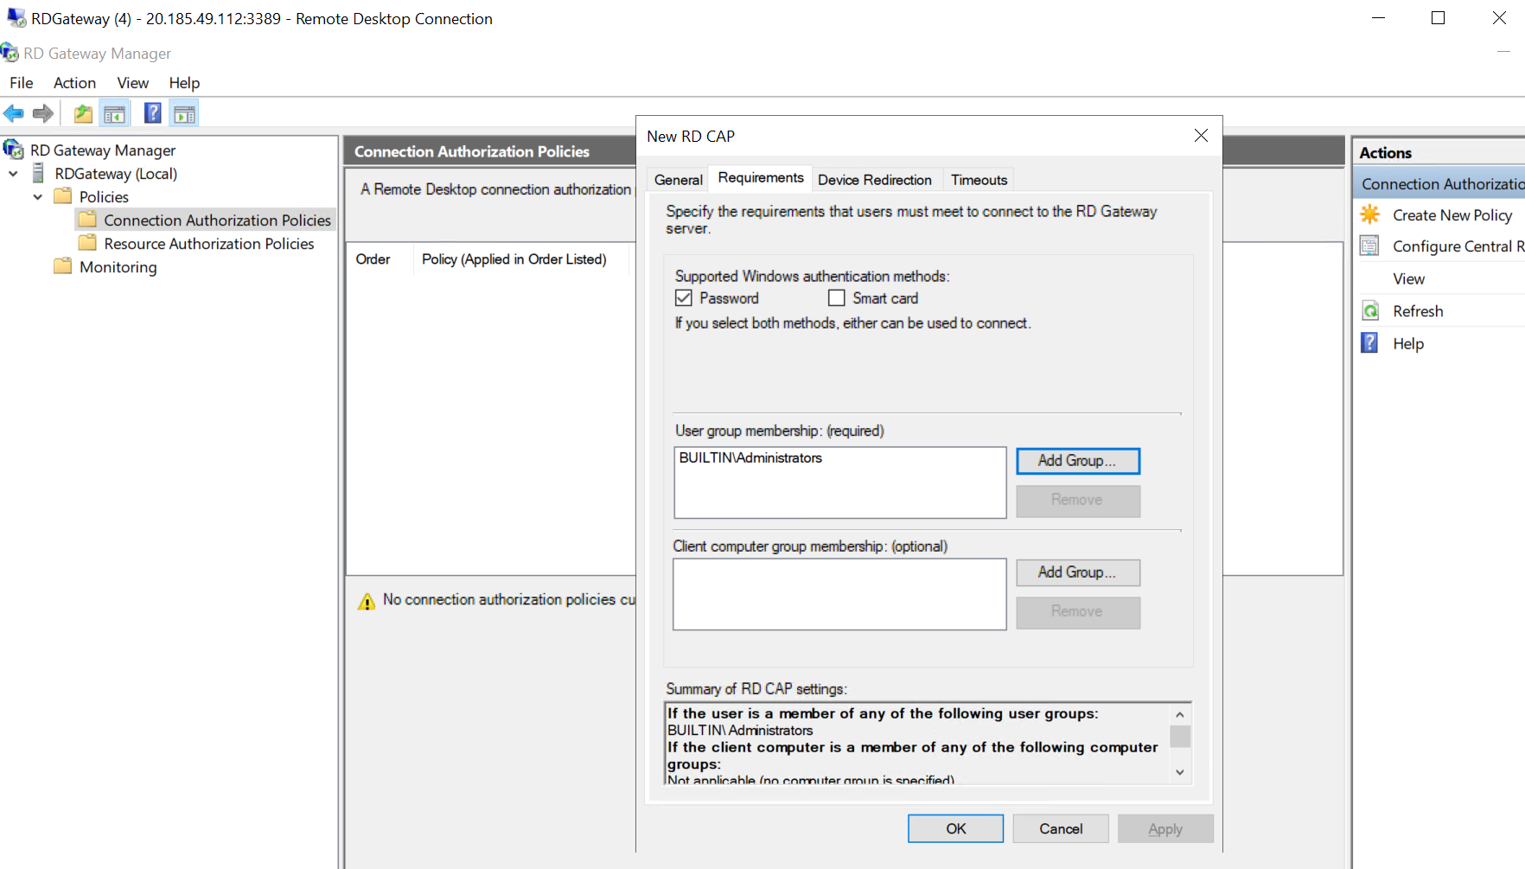

1. **Expand Resource Authorization Policies (RAP) →**

* Right-click → **Create New Policy**.
* Name: Administrators-RAP.
* Add **Computer Group** → add w1, w2, WS11 or any internal servers.
* Click Finish.

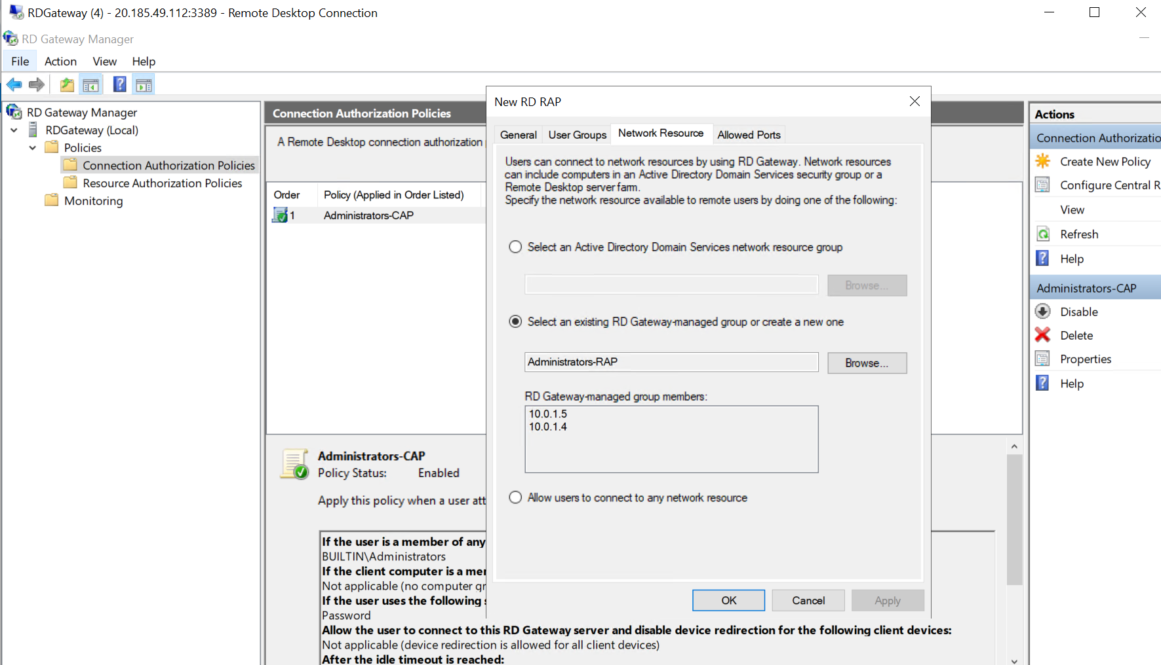

* **STEP 8 — Restart Services**

1. Open **Services.msc**.
2. Locate **and restart:**

* *World Wide Web Publishing Service (W3SVC)*
* *Remote Desktop Gateway (TSGateway)*

1. Wait until **Status = Running**.

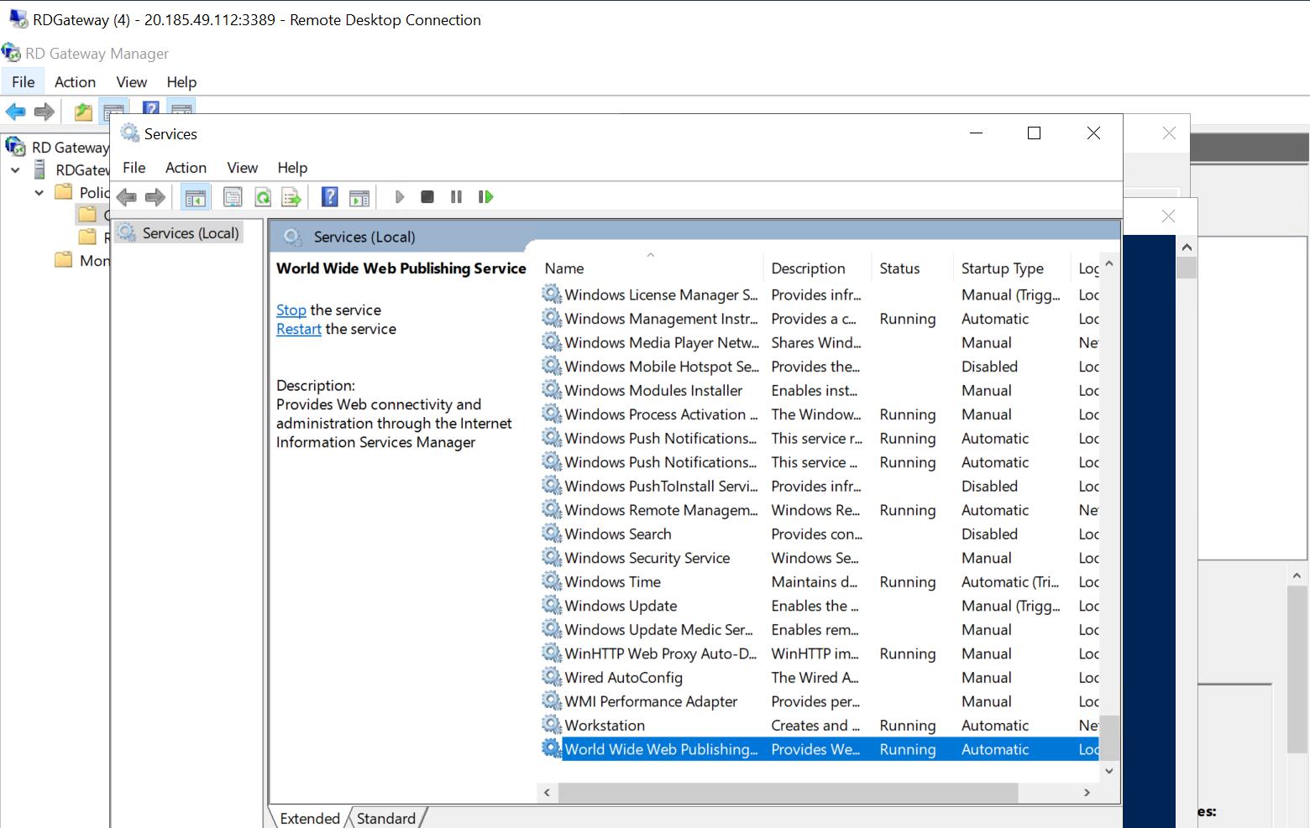

* **STEP 9 — Test the RD Web Portal**

1. Open a browser on the same server or remote client.
2. Navigate to
3. https://20.185.49.112/RDWeb
4. If it shows a certificate warning → click **Continue to site** (it’s self-signed).
5. You should see **RD Web Access login page**.

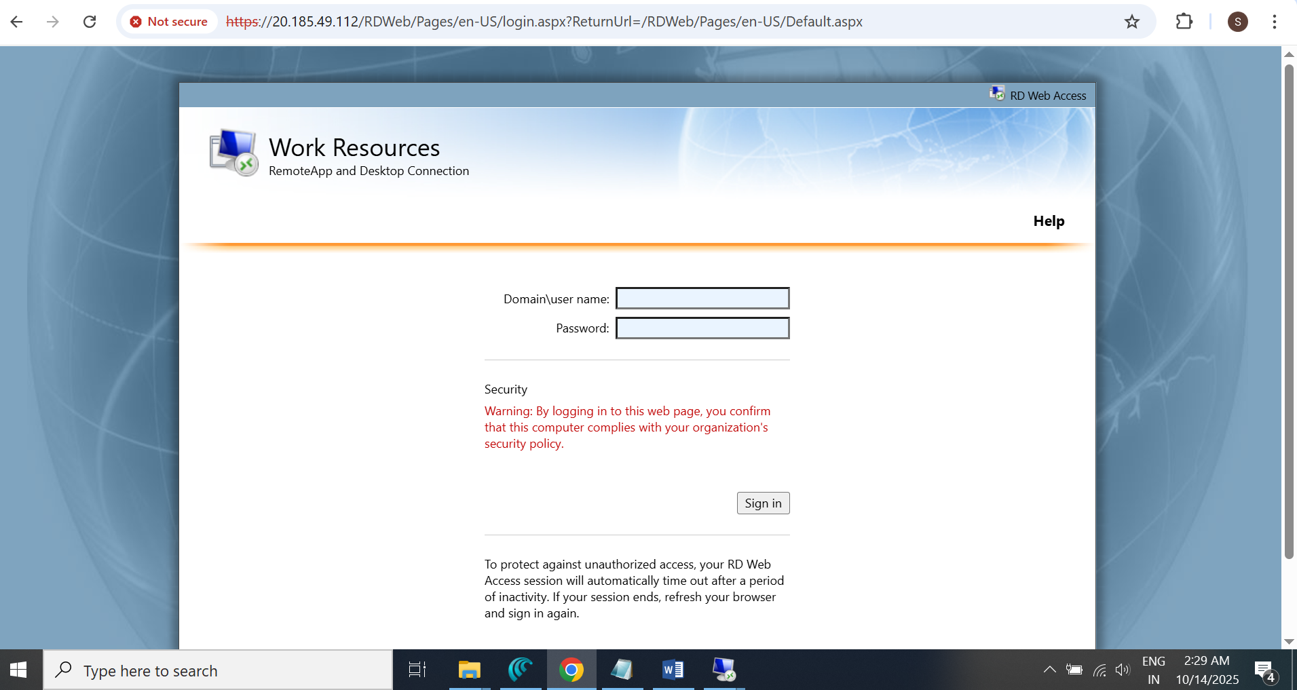

* **LOGIN 🡪**

## **Task IV — Setup Storage Solutions & Verification**

### Objective

Deploy resilient storage, map file share, and verify connectivity.

### Steps

## **Shared Access Signature (SAS)**

* **SAS** = temporary, restricted access token generated from your storage account.

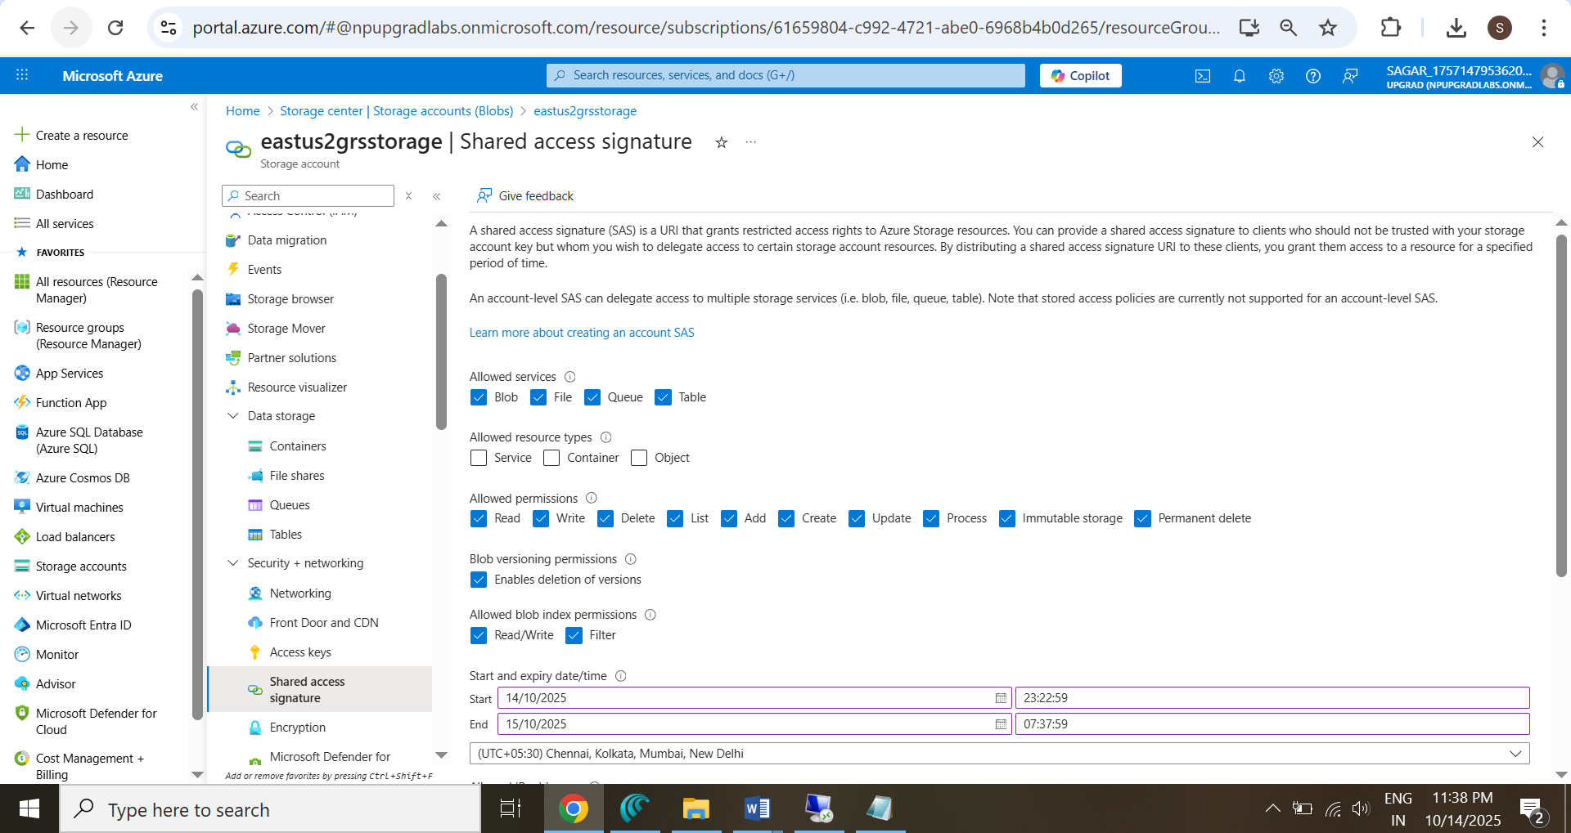

## **Access Keys Verification**

* **Access keys =** full admin access for storage

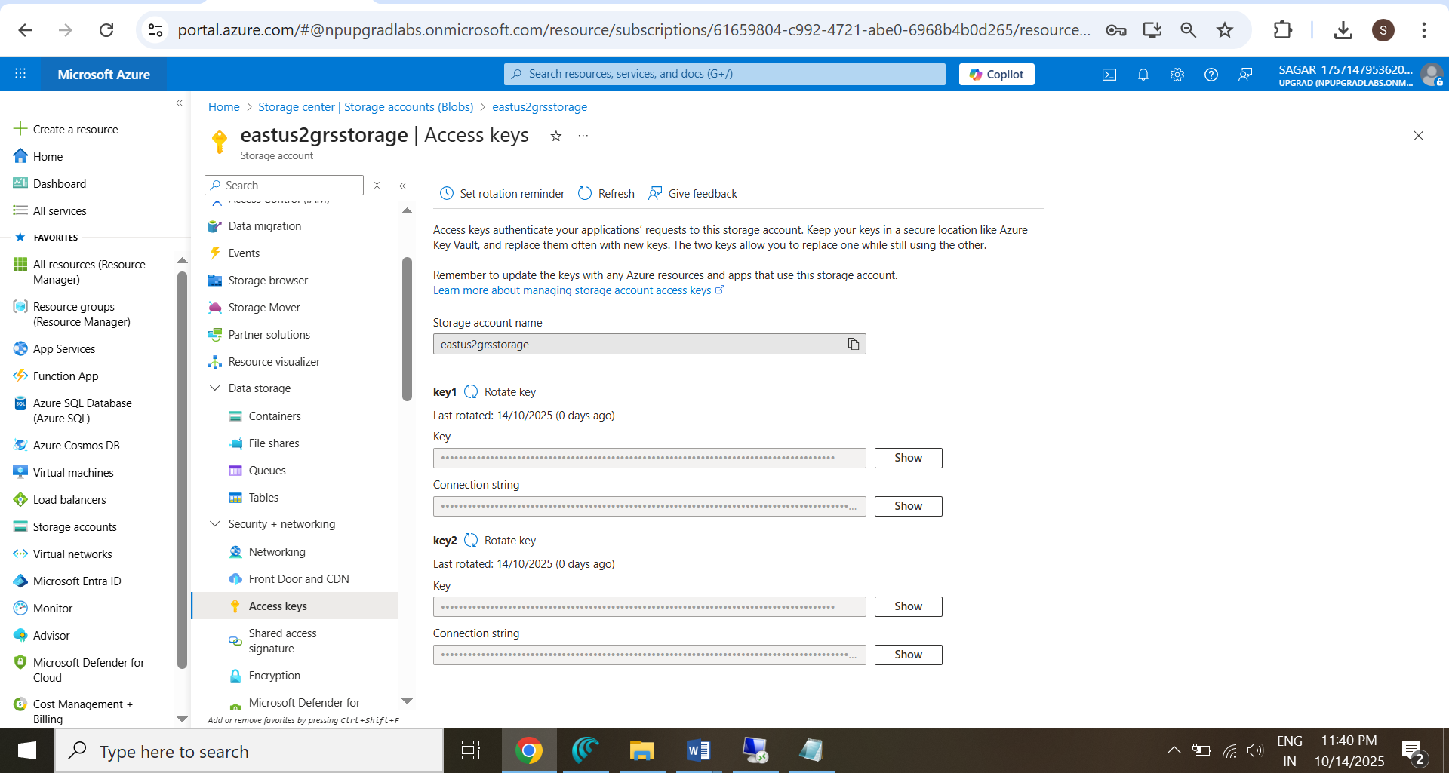

## **Role-Based Access Control (RBAC) Verification**

* **RBAC =** identity-based access via Azure AD roles.

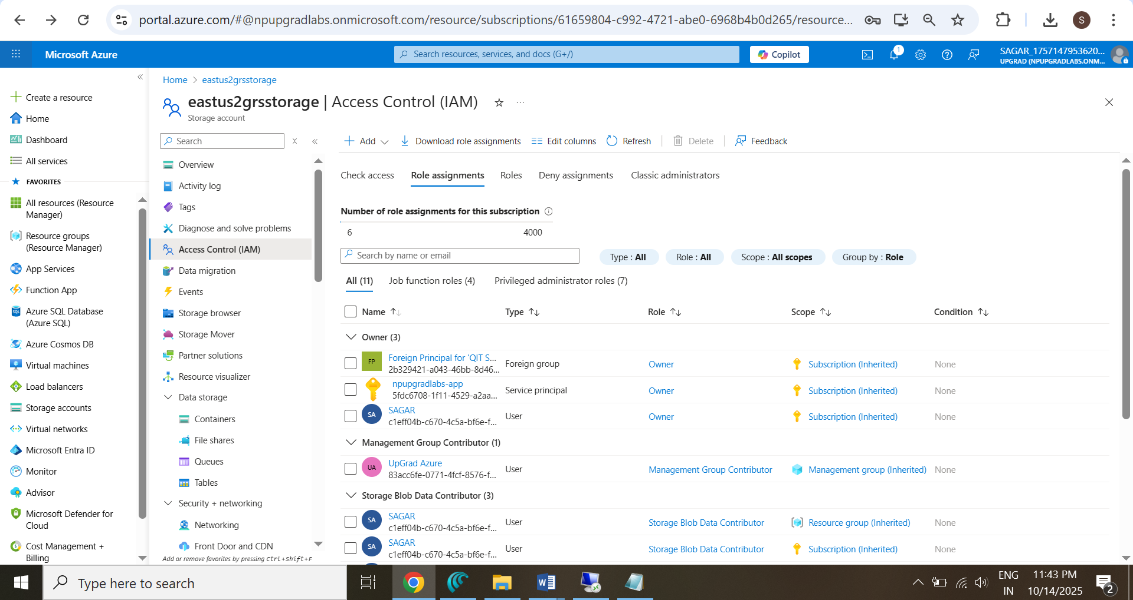

1. **Verify Storage Accounts**
   * **eastuszrsstorage** → SKU = LRS.

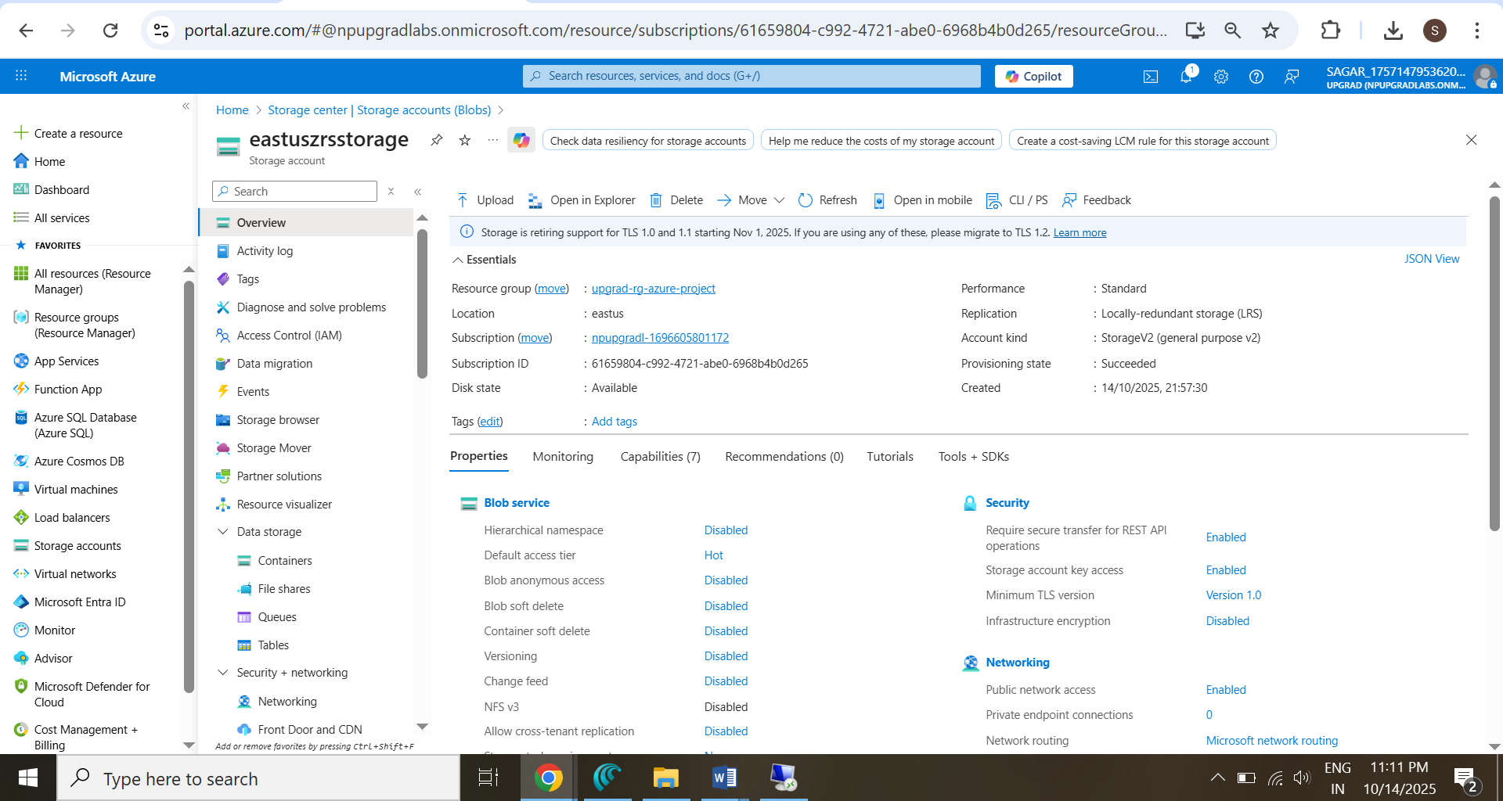

* + **eastus2grsstorage →** SKU = GRS**.**

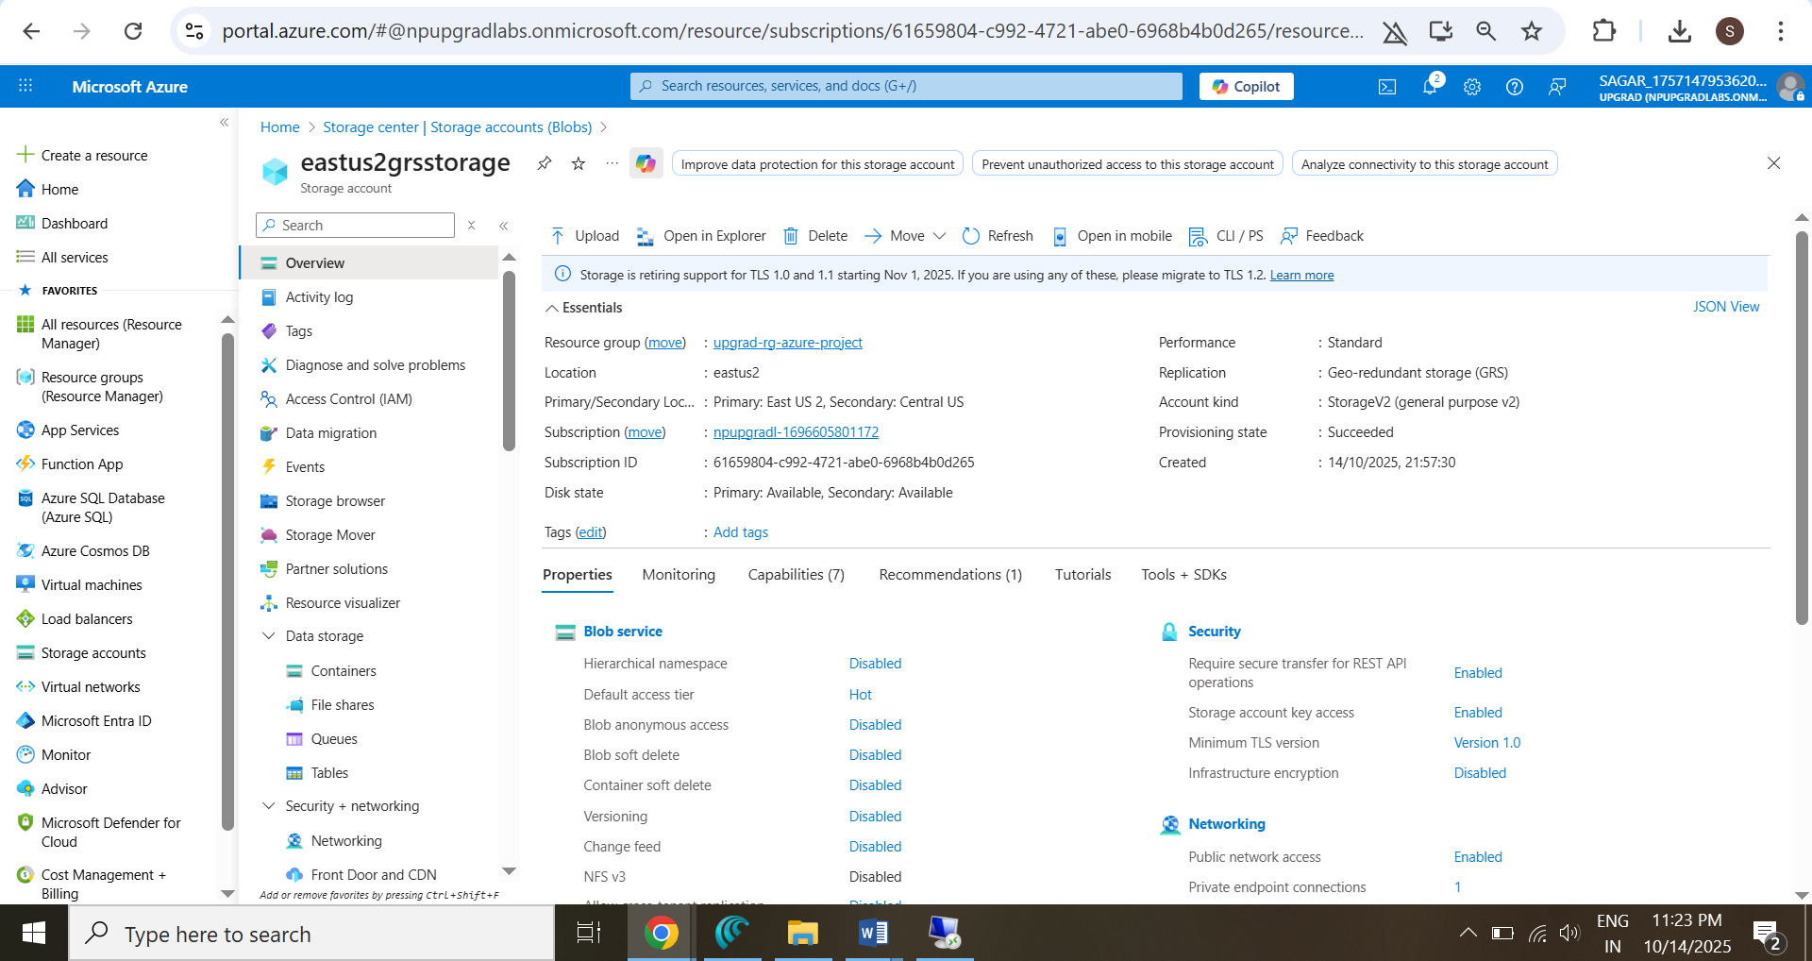

1. **Create File Share**
   * In **eastus2grsstorage** → File shares → **WS11Files**.

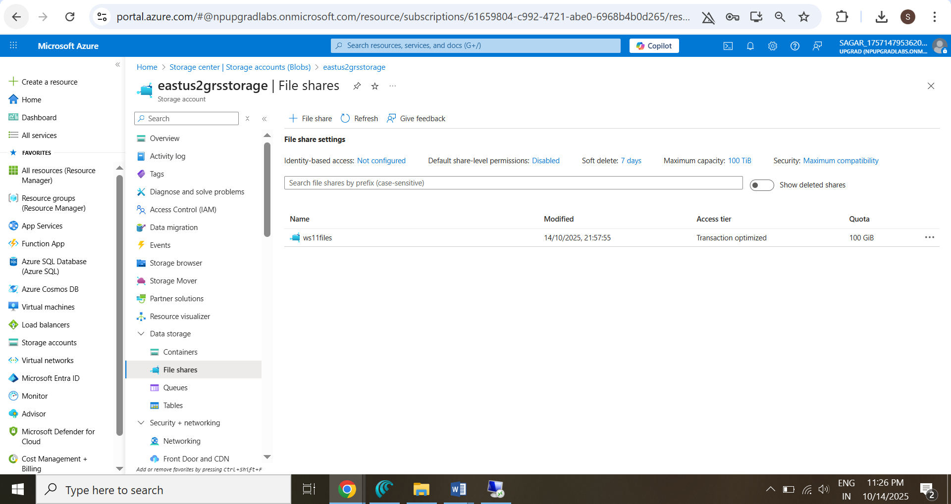

1. **Map S: Drive on WS11**
   * **RDP** to **RDGateway** → connect to **WS11.**
   * Run **PowerShell** 🡪

net use S: \\eastus2grsstorage.file.core.windows.net\WS11Files /u:Azure\eastus2grsstorage Ue7QAJVDtlnmYASf5kAip7X71Kp26nR9dFgr6qBokJg3mv3RkcOVzdnYfW9hKf8VDzD3aSh2lPm7+AStCY4lHQ==

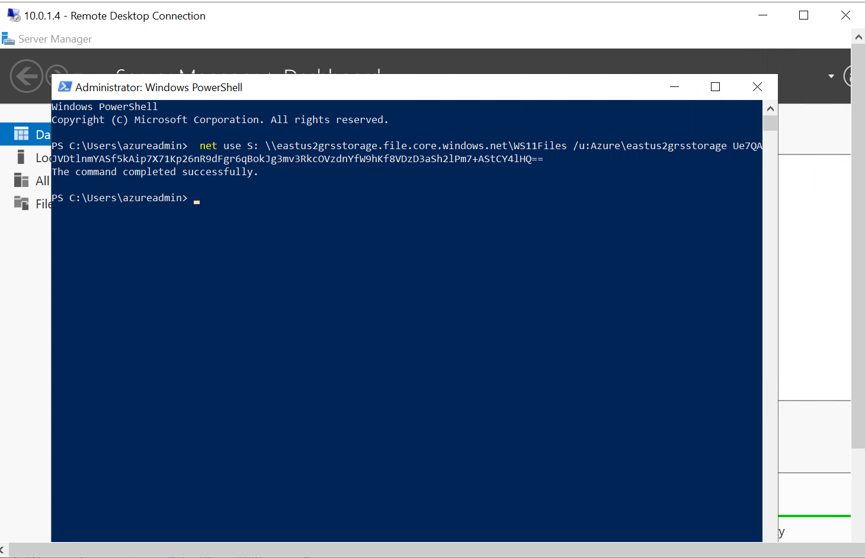

* + Verify in File Explorer **→ S: drive.**

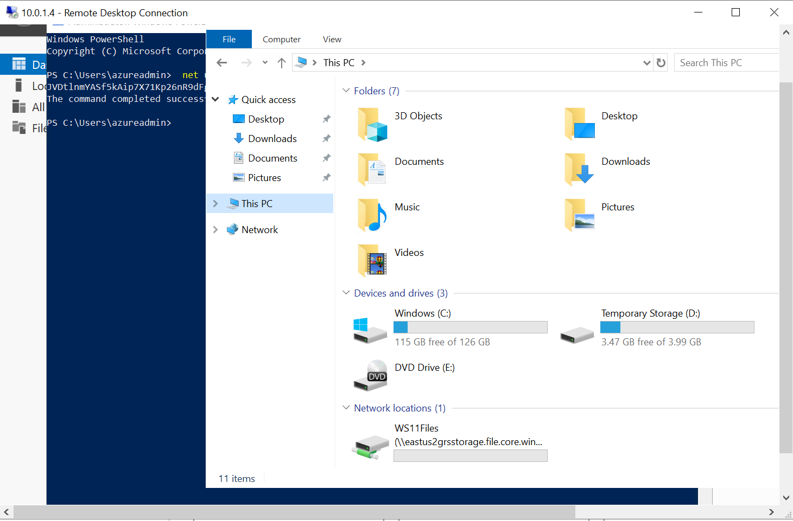

1. **Connectivity Tests**
   * **Ping between w1, w2, and WS11.**

**From W1 🡪**

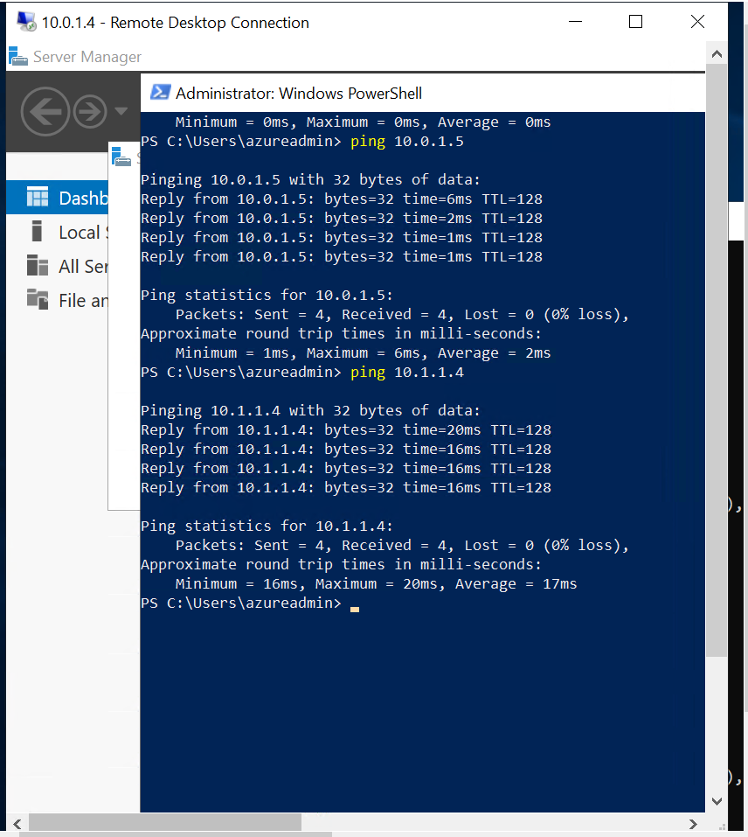

**From W2 🡪**

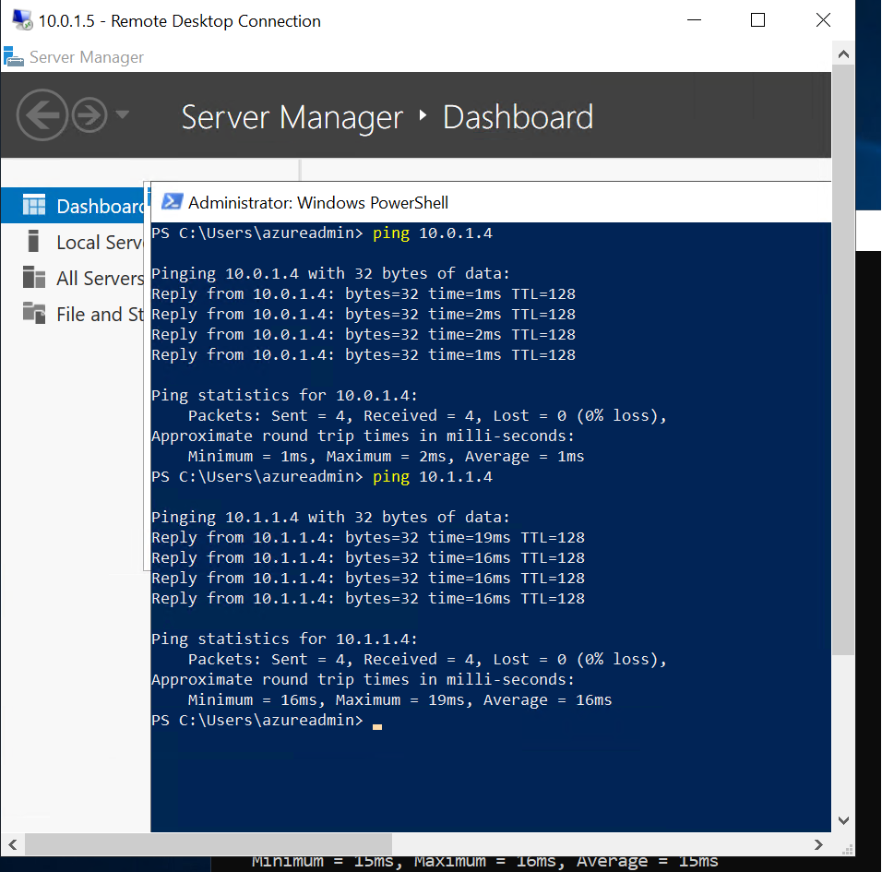

* + Access **Load Balancer HTTP** from browser.



### 🔍 Verification

**Web page accessible**



* **Visual Diagram:**
* **Project Architecture Diagram🡪**

